
EASTERN INTERNATIONAL UNIVERSITY
SCHOOL OF COMPUTING AND INFORMATION TECHNOLOGY


OmniPlant - Manufacturing ERP - Capstone Project 2

Tran Quoc An - 2231200001
Nguyen Phuc Hau - 2231200065
Dang Cao Cuong - 2231200087

Software Engineering

Ho Chi Minh City, August, 2026
EASTERN INTERNATIONAL UNIVERSITY
SCHOOL OF COMPUTING AND INFORMATION TECHNOLOGY

OmniPlant - Manufacturing ERP - Capstone Project 2

Tran Quoc An - 2231200001
Nguyen Phuc Hau - 2231200065
Dang Cao Cuong - 2231200087

Software Engineering

Ho Chi Minh City, August, 2026

ABSTRACT
Manufacturing digitalization responds to the need for reliable information across orders, inventory and production. A World Bank study identifies gaps in Vietnamese firms' use of technology for production planning and quality control [1]. Binh Duong provides a relevant setting: a March 2024 official conference paper records 29 industrial parks and 12 industrial clusters [2]. These figures describe the industrial environment, while local SME research documents conditions affecting digital adoption [3]. Reported SAP Business One and ERPNext deployments provide concrete evidence that manufacturers seek integrated systems to address fragmented records and limited operational visibility [4], [5]. This evidence motivates OmniPlant, a focused Manufacturing Enterprise Resource Planning application for small and medium-sized assembly manufacturers.
Capstone Project 2 develops a web-based application connecting confirmed Sales Orders, Material Requirements Planning, Work Orders, material issues, manual production records and quality-controlled finished-goods inventory. The design separates reserved and quality-restricted stock and preserves links between demand, production documents and lots. Chapter 4 presents implementation and demonstration evidence; Section 4.3 distinguishes frontend testing from outstanding backend transaction checks. The contribution is a focused, inspectable production workflow addressing the information-coordination need identified in this report. Technical readiness is evaluated through the project's own implementation and tests. Benefits for a participating manufacturer will require a field pilot. Capstone 3 prioritizes purchasing-to-stock and delivery-to-payment; detailed costing, machine integration and automatic scheduling remain longer-term work.

ACKNOWLEDGEMENT
First and foremost, we would like to express our deepest gratitude to our project supervisor, Mr. Ha Minh Ngoc, for his invaluable guidance, continuous support and constructive feedback throughout the Capstone Project 2 implementation phase. His academic insight and careful reviews helped the team convert the Capstone 1 design into a coherent, testable and deployable Manufacturing ERP production loop.
We are grateful to the faculty members of the School of Computing and Information Technology at Eastern International University for the technical foundation, facilities and academic environment provided throughout the project.
Finally, we thank our families, peers and team members for their patience, motivation and close collaboration during the design, implementation, integration, testing and documentation of OmniPlant.

TABLE OF CONTENTS
ABSTRACT I
ACKNOWLEDGEMENT II
TABLE OF CONTENTS III
LIST OF FIGURES VI
LIST OF TABLES VIII
LIST OF ABBREVIATIONS IX
CHAPTER 1. INTRODUCTION 1
1.1. Project Background 1
1.2. Problem Statement 2
1.3. Project Objectives 3
1.4. Project Scope 4
1.4.1. In-Scope for Capstone Project 2 4
1.4.2. Out-of-Scope and Deferred 5
1.5. Capstone Project 2 Contributions 5
1.6. Report Structure 6
CHAPTER 2. RELATED WORKS 7
2.1. Evidence of ERP Adoption and Business Demand 7
2.2. Implications for OmniPlant 8
CHAPTER 3. SYSTEM ARCHITECTURE, ANALYSIS, DESIGN AND IMPLEMENTATION 9
3.1. Chapter Overview 9
3.2. System Architecture 9
3.2.1. Architectural Style 9
3.2.2. Technology Stack 10
3.3. Functional Analysis and Actor Model 11
3.3.1. System Actors 11
3.3.2. Use Case Model 12
3.4. End-to-End Business Process Design 13
3.4.1. System Setup and Access Control 15
3.4.2. Sales and Material Planning 15
3.4.3. Purchasing Flow (Deferred Target Process) 16
3.4.4. Manufacturing Execution Flow 16
3.4.5. Receipt, Quality, and Inventory Update 17
3.5. Database Design 17
3.5.1. Data Modeling Principles 17
3.5.2. System Administration and Integration ERD 17
3.5.3. Product and Production Master Data ERD 19
3.5.4. Sales and Planning ERD 20
3.5.5. Purchasing ERD (Designed Only and Deferred) 21
3.5.6. Inventory and Warehouse ERD 22
3.5.7. Manufacturing Execution and Quality ERD 23
3.5.8. Cross-Module Data Relationships 25
3.6. Business Rules and State Controls 26
3.7. API, Security, and Transaction Resilience 27
3.8. Frontend Interaction Design 27
3.9. System Operation and Deployment 28
3.10. Chapter Summary 29
CHAPTER 4. RESULTS AND DISCUSSION 30
4.1. Implementation Results 30
4.2. API-Backed Interface Evidence 31
4.2.1. Dashboard Overview 31
4.2.2. Item Master 32
4.2.3. Stock Balance 33
4.2.4. Inventory Lots 34
4.2.5. Stock Movement History 35
4.2.6. BOM List 36
4.2.7. Active BOM Detail 37
4.2.8. Multi-Level BOM Tree 38
4.2.9. Sales Order List 39
4.2.10. Sales Order Detail 40
4.2.11. Material Planning Workspace 41
4.2.12. Planning Run Detail 42
4.2.13. Work Order List 43
4.2.14. Work Order Detail 44
4.2.15. Material Issue Workspace 45
4.2.16. Production Execution Workspace 46
4.2.17. Production Receipt List 47
4.2.18. Inventory Lots after Quality Control 48
4.2.19. Login and Session Initialization 49
4.2.20. User Management 50
4.2.21. Role Management 51
4.2.22. Permission Catalog 52
4.2.23. Access Scope Management 53
4.2.24. User Assignment 54
4.2.25. Organization Structure 55
4.2.26. Unit of Measure Management 56
4.2.27. Audit Logs 57
4.3. Validation and Acceptance Results 57
4.4. Operational Demonstration Result 58
4.5. Engineering Discussion 59
4.5.1. Planning Run versus Standalone Production Estimation 59
4.5.2. Immutable Snapshots and Idempotency 59
4.5.3. Availability and Quality Semantics 59
4.5.4. ERP Execution without MES 59
4.6. Known Limitations 59
CHAPTER 5. CONCLUSION AND FUTURE WORK 61
5.1. Conclusion 61
5.2. Future Work 61
REFERENCES 63
APPENDIX 64
A.1. Focused MVP Screen Inventory 64
A.2. End-to-End Demonstration Checklist 64

LIST OF FIGURES
Figure 1. OmniPlant system architecture and major technical components. 10
Figure 2. Use case diagram of OmniPlant actors and major system functions. 12
Figure 3. Swimlane activity diagram of the end-to-end OmniPlant business process. 15
Figure 4. ERD of the System Administration and Integration module. 18
Figure 5. ERD of the Product and Production Master Data module. 19
Figure 6. ERD of the Sales and Planning module. 20
Figure 7. Purchasing ERD (designed only; deferred from Capstone Project 2). 21
Figure 8. ERD of the Inventory and Warehouse module. 22
Figure 9. ERD of the Manufacturing Execution and Quality module. 25
Figure 10. Dashboard with API-backed operational overview and alerts 31
Figure 11. Item Master with item types, UOM and tracking-policy evidence 32
Figure 12. Stock Balance with on-hand, reserved and available quantities 33
Figure 13. Inventory Lots with AVAILABLE, HOLD and REJECTED status evidence 34
Figure 14. Stock Movement history with transaction types and trace references 35
Figure 15. BOM list with active and draft lifecycle visibility 36
Figure 16. Active BOM detail with revision, output quantity and component lines 37
Figure 17. Multi-level BOM tree showing nested sub-assemblies and component quantities 38
Figure 18. Sales Order list with lifecycle and fulfillment status evidence 39
Figure 19. Sales Order detail with line allocation and fulfillment quantities 40
Figure 20. Material Planning workspace with confirmed demand and Planning Run history 41
Figure 21. Planning Run detail with shortage and MAKE/BUY supply decisions 42
Figure 22. Work Order list with production lifecycle status evidence 43
Figure 23. Work Order detail with complete reservation readiness 44
Figure 24. Material Issue workspace with component and issue-history evidence 45
Figure 25. Production Execution workspace with good, scrap and rework quantities 46
Figure 26. Production Receipt list with approval and QC lifecycle states 47
Figure 27. Inventory Lots after QC with AVAILABLE, HOLD and REJECTED output 48
Figure 28. Login interface for session and Plant-scope initialization 49
Figure 29. User management with account lifecycle status 50
Figure 30. Role management with active responsibility groups 51
Figure 31. Permission catalog with resource and action codes 52
Figure 32. Access Scope management across organization levels 53
Figure 33. User Assignment form linking User, Role and Scope 54
Figure 34. Organization structure with Company, Plant and Warehouse evidence 55
Figure 35. UOM management with reusable measurement codes 56
Figure 36. Audit Logs with actor, entity, action and timestamp evidence 57

LIST OF TABLES
Table 1. Capstone Project 2 functional scope 4
Table 2. Capstone Project 2 scope status 5
Table 3. Technology stack. 11
Table 4. Actor responsibilities. 11
Table 5. Cross-module data relationships. 25
Table 6. Core business validation rules. 26
Table 7. Operational startup and verification checklist. 28
Table 8. Capstone Project 2 delivery summary 31
Table 9. Quality and acceptance evidence 58
Table 10. Focused Capstone Project 2 MVP navigation 64

LIST OF ABBREVIATIONS
No. | Term | Meaning
1 | API | Application Programming Interface
2 | BOM | Bill of Materials
3 | ERP | Enterprise Resource Planning
4 | FEFO | First Expired, First Out
5 | FG | Finished Good
6 | JWT | JSON Web Token
7 | MES | Manufacturing Execution System
8 | MPS | Master Production Schedule
9 | MRP | Material Requirements Planning
10 | OEE | Overall Equipment Effectiveness
11 | QC | Quality Control
12 | RBAC | Role-Based Access Control
13 | ROP | Reorder Point
14 | SME | Small and Medium-sized Enterprise
15 | SO | Sales Order
16 | UOM | Unit of Measure
17 | WIP | Work in Progress
18 | WO | Work Order

INTRODUCTION

Project Background
Manufacturing digitalization involves coordinating the records used to accept orders, plan materials and account for production. ERP systems provide a shared application context for these activities; ERPNext describes the operational difficulty of maintaining separate applications and spreadsheets for different business functions [6]. For this project, the relevant need is a controlled connection between sales, planning, inventory and production, so that each decision can be checked against its source documents.
Evidence from Vietnam supports investigating this need. Cirera and colleagues report that only 5.6% of establishments used ERP as their most-used method for business administration, while 14% relied primarily on handwritten methods. The study also identifies technology gaps in production planning, procurement and quality control [9, Sec. 4.1]. These are historical, pre-pandemic survey findings published in 2021, not a current ERP-adoption rate for Binh Duong or a manufacturing-SME-only estimate.
Binh Duong offers a concrete industrial setting for the proposed application. A contribution by the Director of the provincial Department of Justice to a Ministry of Justice conference in March 2024 records 29 industrial parks, 12 industrial clusters and 66,000 domestic enterprises [2]. Separately, VietNamNet's coverage of the provincial SME digital-transformation workshop reports the Deputy Chairperson's statement that the locality had more than 57,000 enterprises, over 97% of which were SMEs [7]. The workshop organizer dates that event to 16 August 2022 [8]. These figures refer to different reporting periods and the provincial geography used at those times; they are not a 2026 census.
Industrial parks and clusters are locations, whereas SME status describes enterprises. The cited enterprise totals span business sectors and do not establish the number of manufacturing SMEs inside those parks. Accordingly, OmniPlant selects small and medium-sized assembly manufacturers in the Binh Duong area as a target segment without treating all local enterprises as confirmed users.
Local research adds evidence about adoption conditions. Nguyen Thanh Phuong, Vo Xuan Vinh and Huynh Thi Phuong Dung analyze 207 responses from employees and managers at selected SMEs in the former Binh Duong area. Their 2026 study reports associations between digital transformation and perceived ease of use, organizational culture, digital business strategy, leadership, employee capability and the technology platform [3]. The sample represents respondents, not 207 independently verified manufacturing firms. For OmniPlant, this supports a design emphasis on understandable workflows and a manageable implementation scope; it does not establish the prevalence of particular stock or BOM errors.
The resulting project proposition is to evaluate an integrated production application for firms whose order, material and production records need closer coordination. Actual adoption of SAP Business One and ERPNext demonstrates that manufacturers have acted on this need [4], [5]. Chapter 2 examines the business problems that prompted those investments. Together with the Vietnamese and local evidence, these cases justify investigating demand in the selected segment. Interviews and a pilot must establish the requirements and expected value for a participating Binh Duong manufacturer.
Capstone 1 established the project concept and prototype. Capstone Project 2 focuses on the production workflow described in Chapters 3 and 4: customer demand is translated into a Planning Run and Work Orders, followed by material issues, manual production confirmation and quality-controlled receipts. Actual progress, scrap, rework and time remain manually entered; machine telemetry is outside this phase.
The intended users are administrators, production managers, warehouse personnel and operators using desktop or tablet interfaces. The design favors consistent lists, forms and document states. Its operational scope is limited to assembly manufacturing with defined Bills of Materials; benefits such as shorter planning time or fewer reconciliation errors remain pilot evaluation objectives, rather than measured outcomes of Capstone 2.

Problem Statement
The national technology-adoption study and the manufacturer cases establish a need to investigate better coordination of operational information [1], [4], [5]. OmniPlant translates this need into the following project requirements. Their relevance and priority for an individual Binh Duong manufacturer will be assessed during field validation; the cited sources do not measure the local frequency of each problem.
For demand and material planning, the project requires planners to reconcile confirmed orders with component requirements and supply decisions. OmniPlant links demand to MRP results and production proposals. The evaluation task is to trace each proposal to its originating order and explain the calculated material requirement.
To establish inventory availability, the project requires a clear distinction between stock physically present, quantities already reserved and material eligible for production. OmniPlant distinguishes on-hand, reserved and available quantities and excludes HOLD and REJECTED lots under its release policy. Validation must demonstrate that a planning decision uses eligible material quantities.
To control engineering definitions, the project requires each production order to retain the product definition used when it was created. OmniPlant uses versioned masters and Work Order snapshots. A validation scenario must show that an existing order preserves its selected BOM and Routing after a master-data change.
For production and quality traceability, the project requires users to reconcile consumed material with produced output and its quality status. OmniPlant connects material issues, production receipts, QC decisions and lots. Evaluation must show that a user can retrieve the source records for a selected output lot and explain its inventory eligibility.
Duplicate submissions, competing reservations and unauthorized access are engineering risks in the proposed shared workflow. Retry-safe commands, transaction checks and Plant-scoped authorization are therefore project requirements. Their acceptance status is stated in Section 4.3; they are not presented as locally surveyed business incidents or as database guarantees established by frontend tests.

Project Objectives
The first objective is to deliver the scoped workflow from confirmed Sales Order demand to QC-approved finished-goods inventory, with source-document links that can be inspected in the Chapter 4 demonstration.
To support material decisions, the project aims to implement Planning Runs, multi-level BOM expansion, safety-stock netting and MAKE/BUY recommendations, and verify the resulting quantities against the project's defined planning rules.
Inventory eligibility will be defined by distinguishing on-hand, reserved and available quantities, excluding HOLD and REJECTED lots under the project policy, and recording inventory effects through traceable movements.
Production history will be preserved by connecting Sales Order lines, Work Orders, selected BOM/Routing definitions, material lots, manual execution records and output lots.
Responsibility and access will be controlled by applying role permissions and Plant/Warehouse scope to protected actions and data. These controls will be evaluated through authorization tests.
Reliable commands will use stable idempotency keys and explicit failure handling, with database-level acceptance required for rollback, concurrency and persisted uniqueness.
Implementation evaluation will distinguish automated client/domain checks, API contracts and live or database evidence. Planning time, reconciliation accuracy and trace retrieval will be measured in a subsequent manufacturer pilot against a documented baseline.

Project Scope

In-Scope for Capstone Project 2
Area | Implemented Capstone Project 2 boundary
Platform and administration | Authentication, rotating session tokens, users, roles, permissions, access scopes, Plant selection and audit visibility.
Manufacturing foundation | UOM, Item Master, Item-Warehouse settings, multi-level BOM, inventory balances, lots and stock movements.
Demand and planning | Sales Orders, confirmed planning demand, immutable Planning Runs, BOM explosion, safety-stock netting, exception reporting and MAKE/BUY suggestions.
Production documents | Work Order creation/conversion, demand allocation, BOM/Routing snapshots, material readiness, release and cancellation.
Execution | Reservation, Material Issue, over-BOM variance seam, manual good/scrap/rework/time confirmation and WIP trace.
Receipt and quality | Partial Production Receipts; separate Manager approval/rejection and QC permissions/actions; approval posts HOLD, then QC sets AVAILABLE or REJECTED. The default Manager may hold both permissions.
Reporting and UX | Inventory Dashboard, low-stock alerts, movements, bilingual EN/VI UI, loading/empty/error states and desktop/tablet support.
Table 1. Capstone Project 2 functional scope

Delivery status | Capstone Project 2 boundary
Implemented | Confirmed SO -> MRP -> MAKE -> Work Order -> Issue -> manual Execution -> Receipt/HOLD -> QC/AVAILABLE; platform, inventory and BOM foundation. Validation boundaries are listed in Section 4.3.
Designed only | Purchasing process and ERD, including suppliers, requisitions, Purchase Orders and Goods Receipts. These are target designs, not Capstone Project 2 implementation results.
Deferred | BUY-to-stock and delivery-to-payment execution: Capstone 3 minimum scope. Detailed costing, MES/OEE and automatic finite scheduling: post-Capstone future work.
Table 2. Capstone Project 2 scope status

Out-of-Scope and Deferred
Supplier lifecycle management, requisitions, Purchase Orders, Goods Receipts and commercial approval are not delivered in Capstone Project 2. The minimum BUY-to-stock slice is planned for Capstone 3; BUY suggestions currently remain read-only and create no scheduled receipt or inventory effect.
Delivery orders, invoicing, payment and customer credit are deferred.
PLC/IoT integration, automatic machine signals, dispatching, downtime and OEE are deferred; Capstone Project 2 uses manual ERP confirmation.
Detailed costing is deferred, including labor, overhead, WIP valuation, comparisons of standard and actual costs, and profitability analysis.
Capacity warnings and Routing context are retained, but automatic finite-schedule optimization is not part of the focused MVP.
The standalone what-if calculator is not included in the Capstone Project 2 production scope because the API-backed Planning Run is the authoritative MRP function.

Capstone Project 2 Contributions
The project contribution is the implementation and evaluation of a bounded production application addressing the information-coordination need discussed in this chapter. The document links and interface evidence in Section 4.2 allow reviewers to inspect how demand, planning, material issues and finished output are related. The contribution is assessed through the implemented scope, traceability and acceptance evidence in Chapters 3 and 4.
The proposed value for the target user is easier reconciliation of production decisions with material and quality records. That value will be assessed through the pilot tasks defined in Chapter 5. The implemented behavior and the remaining assurance limitations must be read together with Sections 4.3 and 4.6; no customer deployment or quantified productivity improvement is claimed.

Report Structure
Chapter 1 introduces the evidence for the target setting, operational problem, objectives, scope and project contribution.
Chapter 2 examines evidence of ERP adoption and the business needs motivating digitalization, then relates those needs to the purpose and evaluation of OmniPlant.
Chapter 3 documents architecture, actors, modules, workflows, business rules, APIs, security, traceability and system operation.
Chapter 4 presents implemented results, API-backed interface evidence, testing outcomes, limitations and engineering discussion.
Chapter 5 concludes the Capstone Project 2 phase and defines the Capstone 3 roadmap.

RELATED WORKS

Evidence of ERP Adoption and Business Demand
Manufacturers' decisions to implement ERP provide observable evidence of demand for integrated operational information. The following SAP Business One and ERPNext cases identify the problems that prompted adoption and the information needs those firms sought to address [4], [5]. These accounts complement the Vietnamese technology-adoption evidence and the Binh Duong SME context presented in Chapter 1 [1]-[3].
The case study of Green Line Botanicals published by Softengine describes a manufacturer managing accounting, inventory and production through disconnected systems and extensive manual documentation. Growth made consolidation difficult, while ingredient shortages affected order fulfillment. The company selected SAP Business One with Softengine production-scheduling software to improve operational visibility and information coordination [4]. The case documents a concrete business reason to invest in ERP: fragmented information was constraining the firm's ability to manage materials and serve customers.
A first-person account by CVS Group's Finance Director, Umair Sayed, describes ERPNext adoption across manufacturing companies in the UAE, Qatar and Pakistan. Inventory and invoicing relied on Excel, and management lacked live access to financial information. The group sought a web-based system and consolidated reporting. The account reports that ERPNext entered operational use at CVS Doha and CVS Sharjah in 2017, followed by implementation at Aftab Engineering Services in 2018 [5]. These decisions show that a need for accessible, connected business data led to ERP implementation.
The evidence has a defined scope. Green Line's account was published by its implementation provider; the CVS account was published on Frappe's blog by a participant in the deployment. Both describe specific organizations, and the CVS account also records implementation limitations [4], [5]. They support the existence of ERP demand in manufacturing, while demand among Binh Duong assembly SMEs must be established through local engagement.
For the target setting, the relevant evidence therefore combines local industrial scale and SME digital-adoption conditions with examples of actual manufacturer investment in ERP [2], [3], [4], [5], [7], [8]. This supports a practical research question for OmniPlant: can a focused application help a participating assembly manufacturer coordinate demand, stock and production information with an acceptable implementation effort?
Taken together, the sources support the conclusion that the need for ERP and digitalization is real: firms have adopted integrated systems in response to operational information problems [4], [5]. They justify investigating an application in this problem area. Whether OmniPlant meets a particular firm's needs remains an evaluation question, to be answered using the project's acceptance evidence and a manufacturer pilot.

Implications for OmniPlant
OmniPlant selects a limited assembly-production flow: confirmed demand, material planning, Work Orders, issues, manual execution, receipt approval and QC-released output. Chapters 3 and 4 describe the design and implementation evidence. Procurement execution is reserved for Capstone 3. This choice keeps the project deliverable aligned with a demonstrable document flow.
The business rationale is the documented need for coordinated operational information and the local conditions for digital adoption [1], [3]-[5]. OmniPlant addresses a selected part of that need within its assembly-production scope. Technical feasibility is assessed using the architecture, implementation and tests presented in Chapters 3 and 4. Database rollback, concurrent reservation and idempotency reruns still require acceptance as stated in Section 4.3.
The local study motivates attention to usability and organizational readiness [3]. A manufacturer pilot should establish current information problems, document the time and effort required for representative tasks, and assess user completion after training. The proposed evaluation will determine whether the selected scope is useful and practical for the participating firm. Deployment cases support the demand rationale; measured pilot results must establish OmniPlant's own value.
Within this scope, Planning Runs are the operational MRP function. A standalone what-if estimator is not part of the Capstone 3 extensions defined in Section 5.2.

SYSTEM ARCHITECTURE, ANALYSIS, DESIGN AND IMPLEMENTATION

Chapter Overview
This chapter presents the analysis, architectural design, business-process design, database structure, and implementation principles of OmniPlant. The chapter begins with the overall technical architecture and actor model before describing how the main actors interact with the system. It then explains the end-to-end operational workflow through a swimlane activity diagram.
The database design is divided into six major functional modules. This modular presentation makes the data model easier to understand while preserving the relationships among administration, master data, sales and planning, purchasing, inventory, and manufacturing execution. The final sections describe the core business rules, API and security design, frontend interaction principles, and deployment environment.

System Architecture

Architectural Style
OmniPlant is implemented as a web-based Manufacturing ERP system using a modular-monolith architecture. This approach maintains a single deployable backend while separating the application into clear functional modules. It provides simpler deployment and transaction management than a distributed microservice architecture while still preserving domain boundaries.
The frontend is responsible for user interaction, client-side validation, permission-aware navigation, query state, internationalization, and responsive presentation. The backend remains the authoritative source for authentication, authorization, business-state transitions, inventory effects, material planning calculations, approval rules, and database consistency.
PostgreSQL stores transactional and master data, while Redis supports session and token-management functions. Communication between the frontend and backend is performed through RESTful API endpoints under the /api/v1 namespace.

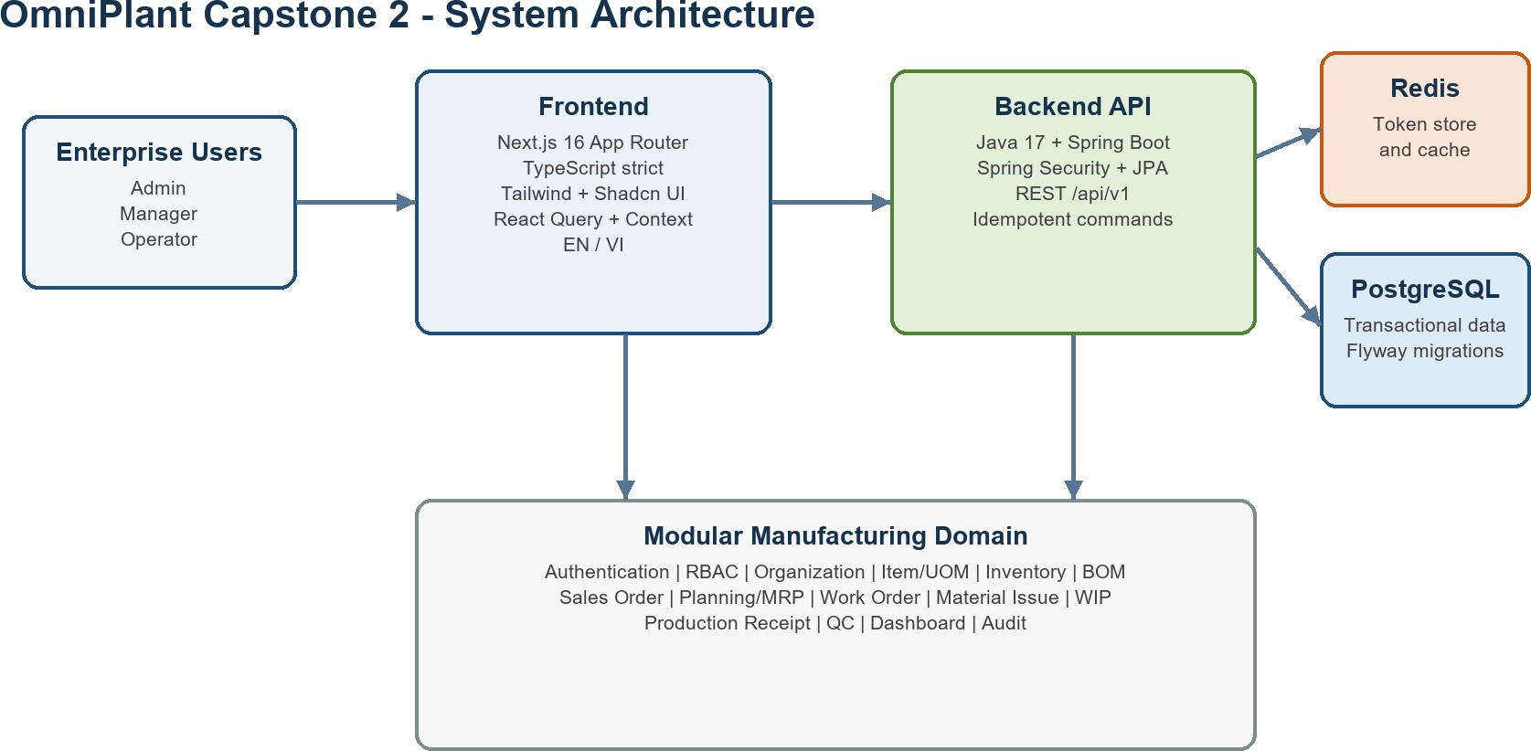

Figure 1. OmniPlant system architecture and major technical components.
The architecture separates presentation concerns from business authority. Although the frontend prevents invalid actions where possible, all critical rules are revalidated by the backend. This includes Plant and Warehouse access, Work Order release readiness, material availability, approval permissions, quality disposition, and idempotent inventory transactions.

Technology Stack
The major technologies and their responsibilities are summarized in the following table.

Layer | Technology and responsibility
Frontend | Next.js App Router, React, and strict TypeScript.
UI and styling | Tailwind CSS, customized Shadcn UI, and Lucide icons.
Client state | React Query for server state and Context API for authentication and selected Plant.
Internationalization | next-intl with English and Vietnamese namespaces.
Backend | Java 17, Spring Boot, Spring Security, and JPA/Hibernate.
Persistence | PostgreSQL with Flyway migrations and Redis for session support.
Integration | RESTful /api/v1 endpoints, UUID identifiers, and a standard response envelope
Table 3. Technology stack.

Functional Analysis and Actor Model

System Actors
OmniPlant defines three primary human actors: Administrator, Manager, and Operator. The actors are separated according to responsibility and authority rather than only by screen visibility.

Actor | Main responsibilities
Administrator | Maintains users, roles, permissions, access scopes, organizational structure, and system-level master data. Reviews audit information and controls access assignments.
Manager | Manages Sales Orders, material planning, supply decisions, Work Orders, purchasing documents, production approvals, quality disposition, and operational monitoring.
Operator | Performs authorized warehouse and production activities, including reservation, material issue, production reporting, goods receipt, and Production Receipt submission.
System | Performs authentication, authorization, MRP calculation, BOM explosion, inventory updates, status transitions, variance calculation, and audit logging.
Table 4. Actor responsibilities.
The System is not a human actor. It represents automated application behavior triggered by the actions of authenticated users.

Use Case Model
The following use case diagram presents the functional boundary of OmniPlant and the interactions between its three human actors and the major system functions.
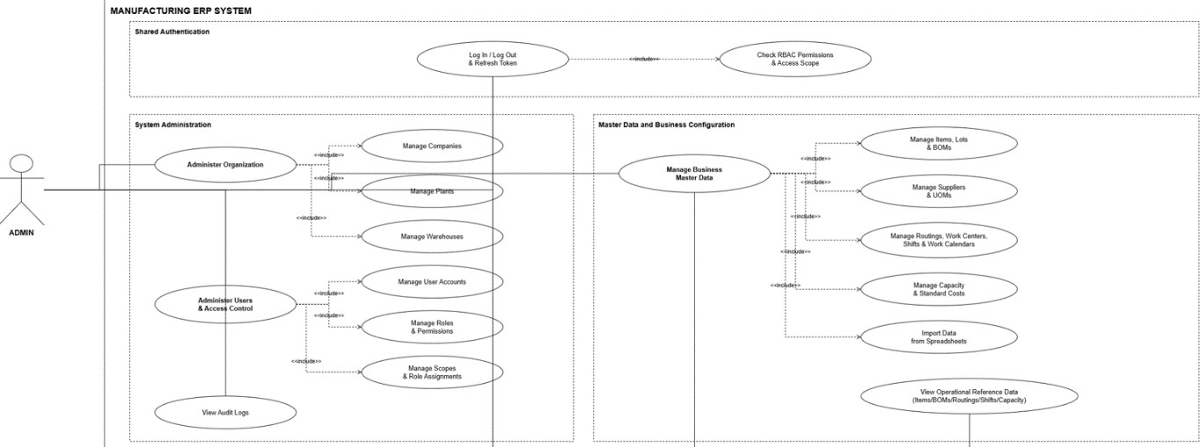
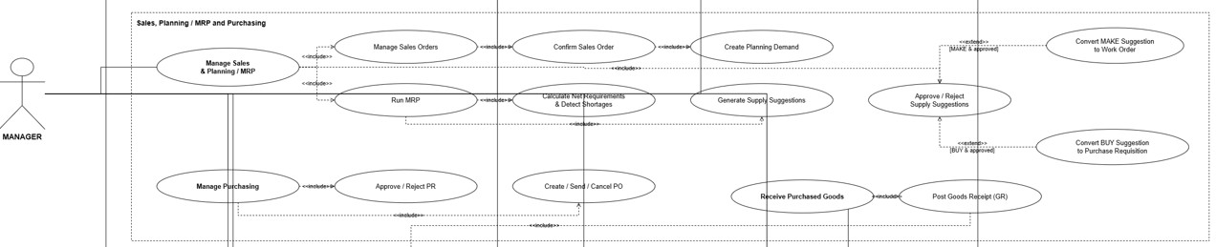
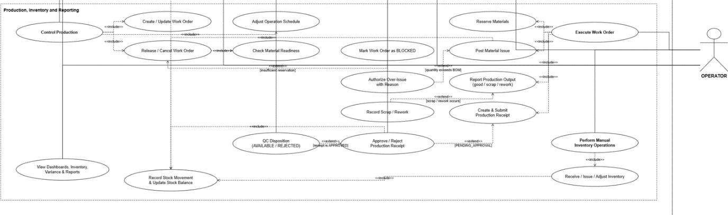

Figure 2. Use case diagram of OmniPlant actors and major system functions.
The use case diagram describes functional responsibility but does not represent execution order. Administrator use cases focus on system configuration, organizational data, access control, and auditability. Manager use cases cover planning, approval, production control, purchasing, and quality decisions. Operator use cases cover the direct execution of inventory, receiving, and manufacturing activities.
Several use cases are shared between actors but are controlled by different permissions. For example, both Managers and Operators may view Work Orders, while only authorized Managers can create or release them. Operators may create and submit Production Receipts, but they cannot approve their own receipts or perform final quality disposition. This separation of duties prevents the same user from executing and approving an integrity-sensitive transaction.

End-to-End Business Process Design
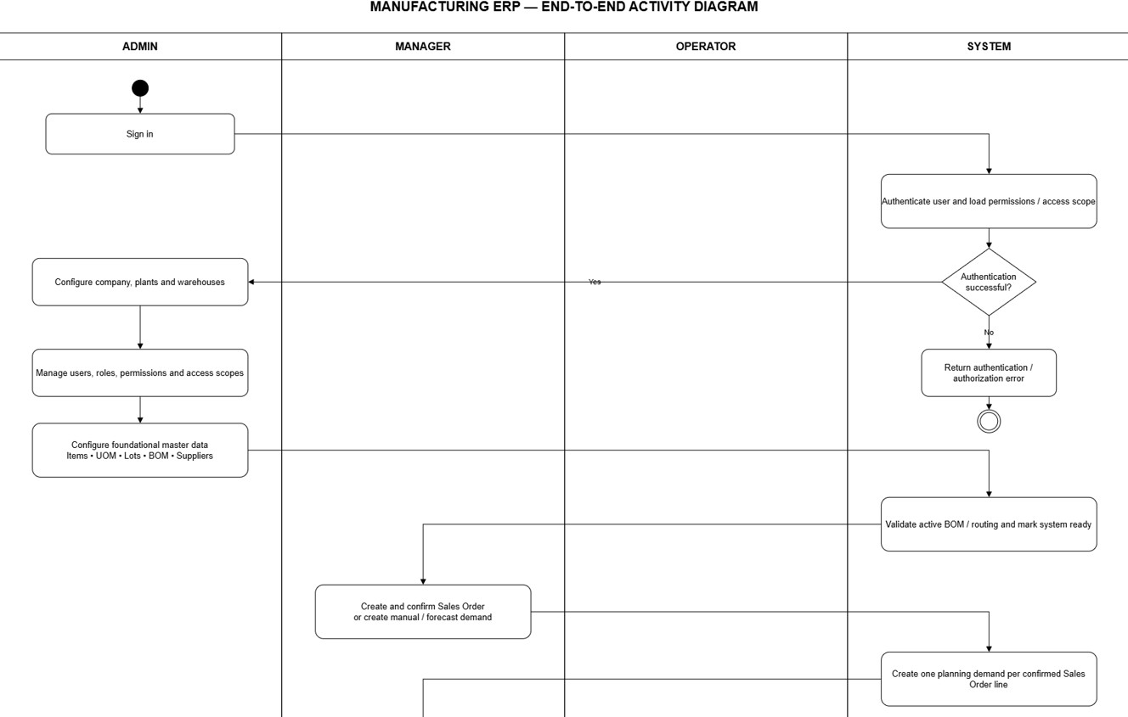
The operational behavior of OmniPlant is document-driven. A user cannot move directly from demand to inventory output without passing through the required planning, production, approval, and quality-control documents. The following workflow is divided into four swimlanes: Administrator, Manager, Operator, and System.

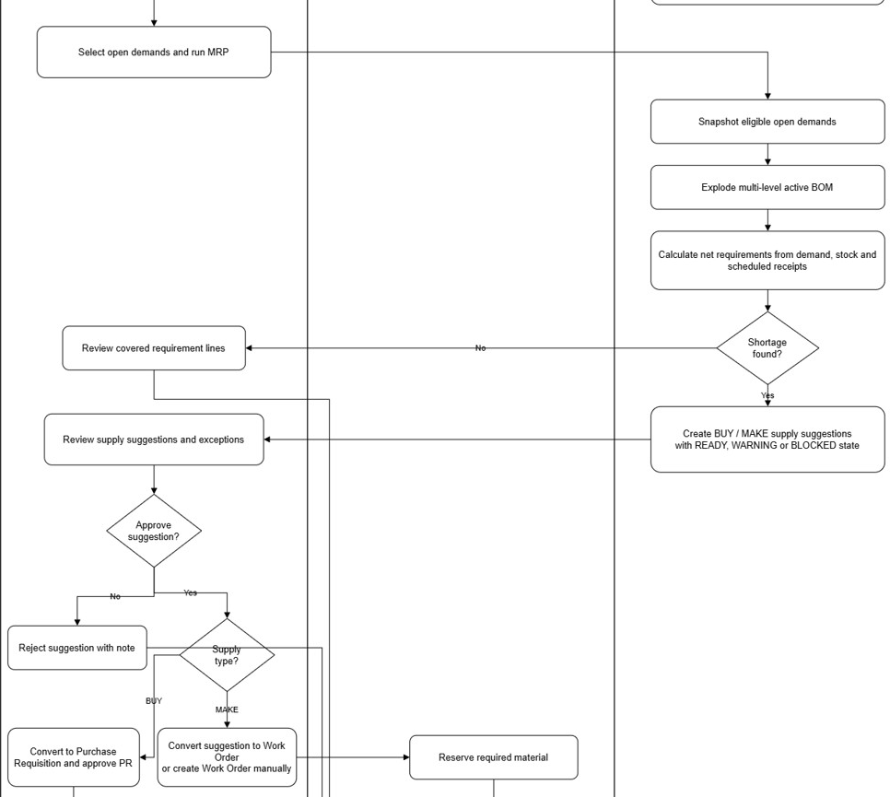
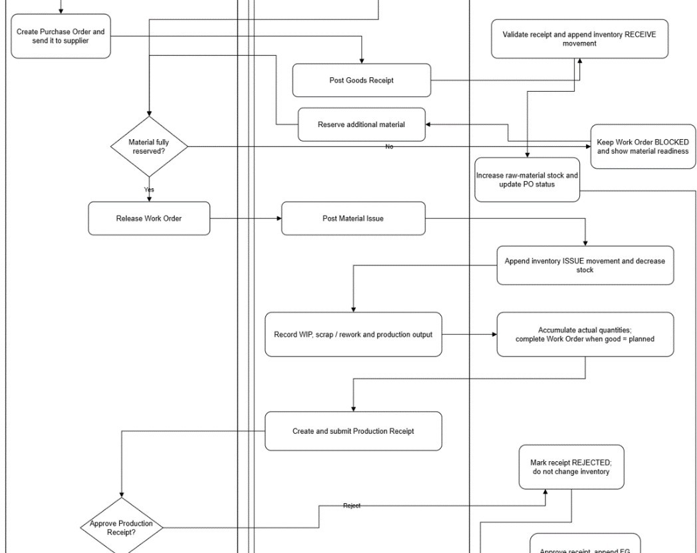
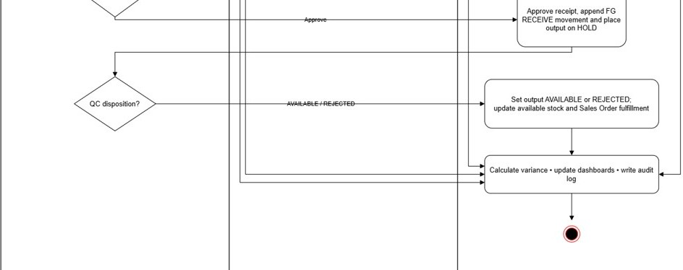

Figure 3. Swimlane activity diagram of the end-to-end OmniPlant business process.
The swimlane diagram identifies both execution sequence and responsibility. Human decisions are assigned to the role that owns the business outcome, while validation, calculation, inventory posting, and audit recording are placed in the System lane. The diagram also demonstrates that the Administrator prepares the operating environment but does not participate directly in daily purchasing or production execution.

System Setup and Access Control
The process begins with authentication and authorization. The System validates the user credentials and loads the corresponding roles, permissions, and access scopes. If authentication fails, the request is rejected without entering the business workflow.
Before operational activities begin, the Administrator configures the Company, Plants, Warehouses, users, roles, permissions, and access scopes. Foundational master data such as units of measure, Items, Bills of Materials, suppliers, Routings, Work Centers, shifts, and work calendars must also be available according to the relevant module permissions.
The System validates important master-data invariants. Examples include preventing circular BOM structures, requiring an active BOM for material explosion, and ensuring that production master data belongs to the correct Company or Plant context.

Sales and Material Planning
A Manager creates and confirms a Sales Order or records a manual or forecast demand. Confirmation converts the commercial requirement into an eligible planning demand. Draft Sales Orders do not participate in MRP.
The Manager selects eligible demand and starts an MRP run. The System creates an immutable snapshot of the selected demand, explodes the active multi-level BOM, evaluates eligible inventory and scheduled supply, and calculates the net requirement.
netRequirement = max(0, grossRequirement + stockTarget - projectedAvailable)
If sufficient supply exists, the requirement is marked as covered. Otherwise, the System creates a supply suggestion. A suggestion may recommend purchasing the material or manufacturing it internally. The Manager reviews the suggestion, its exception state, and any missing BOM or Routing information before approving, rejecting, or converting it.

Purchasing Flow (Deferred Target Process)
DESIGNED ONLY - Purchasing flow; not delivered or accepted in Capstone Project 2.
For a BUY requirement, an approved supply suggestion may be converted into a Purchase Requisition. The Manager reviews and approves the requisition before converting it into a Purchase Order and sending the order to the selected supplier.
When the supplier delivers the material, the Operator posts a Goods Receipt. The System validates the Purchase Order line, Warehouse, received quantity, lot information, and idempotency key. A valid receipt creates an inventory RECEIVE movement, increases raw-material stock, and updates the received quantity and status of the Purchase Order.

Manufacturing Execution Flow
For a MAKE requirement, an approved suggestion is converted into a Work Order. The Work Order stores the selected product, planned quantity, output Warehouse, BOM evidence, Routing evidence, and demand allocations.
Materials are reserved before release. Reservation reduces available quantity but does not change physical on-hand stock. If the reservation does not cover all component requirements, the System keeps the Work Order in the BLOCKED state and reports the missing quantities. After sufficient material is reserved, the Manager releases the Work Order.
The Operator posts a Material Issue for eligible reserved components. The System creates an inventory ISSUE movement and decreases the corresponding stock balance. Issues above the Work Order BOM requirement require an explicit reason and an authorized override.
During production, the Operator records good, scrap, and rework quantities. These transactions update the Work Order actual quantities and preserve WIP evidence. OmniPlant records these results manually and does not claim automated MES or machine-data integration.

Receipt, Quality, and Inventory Update
After production output is reported, the Operator creates and submits a Production Receipt. Submission moves the receipt into the PENDING_APPROVAL state without immediately changing inventory.
An authorized Manager may approve or reject the receipt. Rejection requires a reason and has no stock effect. Approval creates a finished-goods RECEIVE movement and places the received output in HOLD status.
Quality disposition is performed separately from receipt approval. An AVAILABLE result releases the output for planning and Sales Order fulfillment. A REJECTED result keeps the quantity unavailable for operational use. The System then updates inventory balances, Sales Order fulfillment, operational dashboards, variance information, and audit logs.

Database Design

Data Modeling Principles
The OmniPlant database uses UUID primary keys and explicit foreign keys for physical relationships. Transactional tables retain timestamps, actor identifiers, and version fields where required for auditability and optimistic concurrency.
The model separates reusable master data, lifecycle-controlled business documents, and append-only ledger or execution evidence. Some fields, such as reference_id, are intentionally polymorphic and therefore do not have a physical foreign key. These fields are documented as logical relationships rather than being presented as database-enforced relationships.
Each ERD is independently readable. A table marked as an external reference contains only the relationship key required by the module diagram; its complete definition is presented in the module that owns the table.

System Administration and Integration ERD
This module defines the organizational and authorization foundation of OmniPlant. It includes users, Companies, Plants, Warehouses, roles, permissions, access scopes, assignments, audit logs, and data-import records.
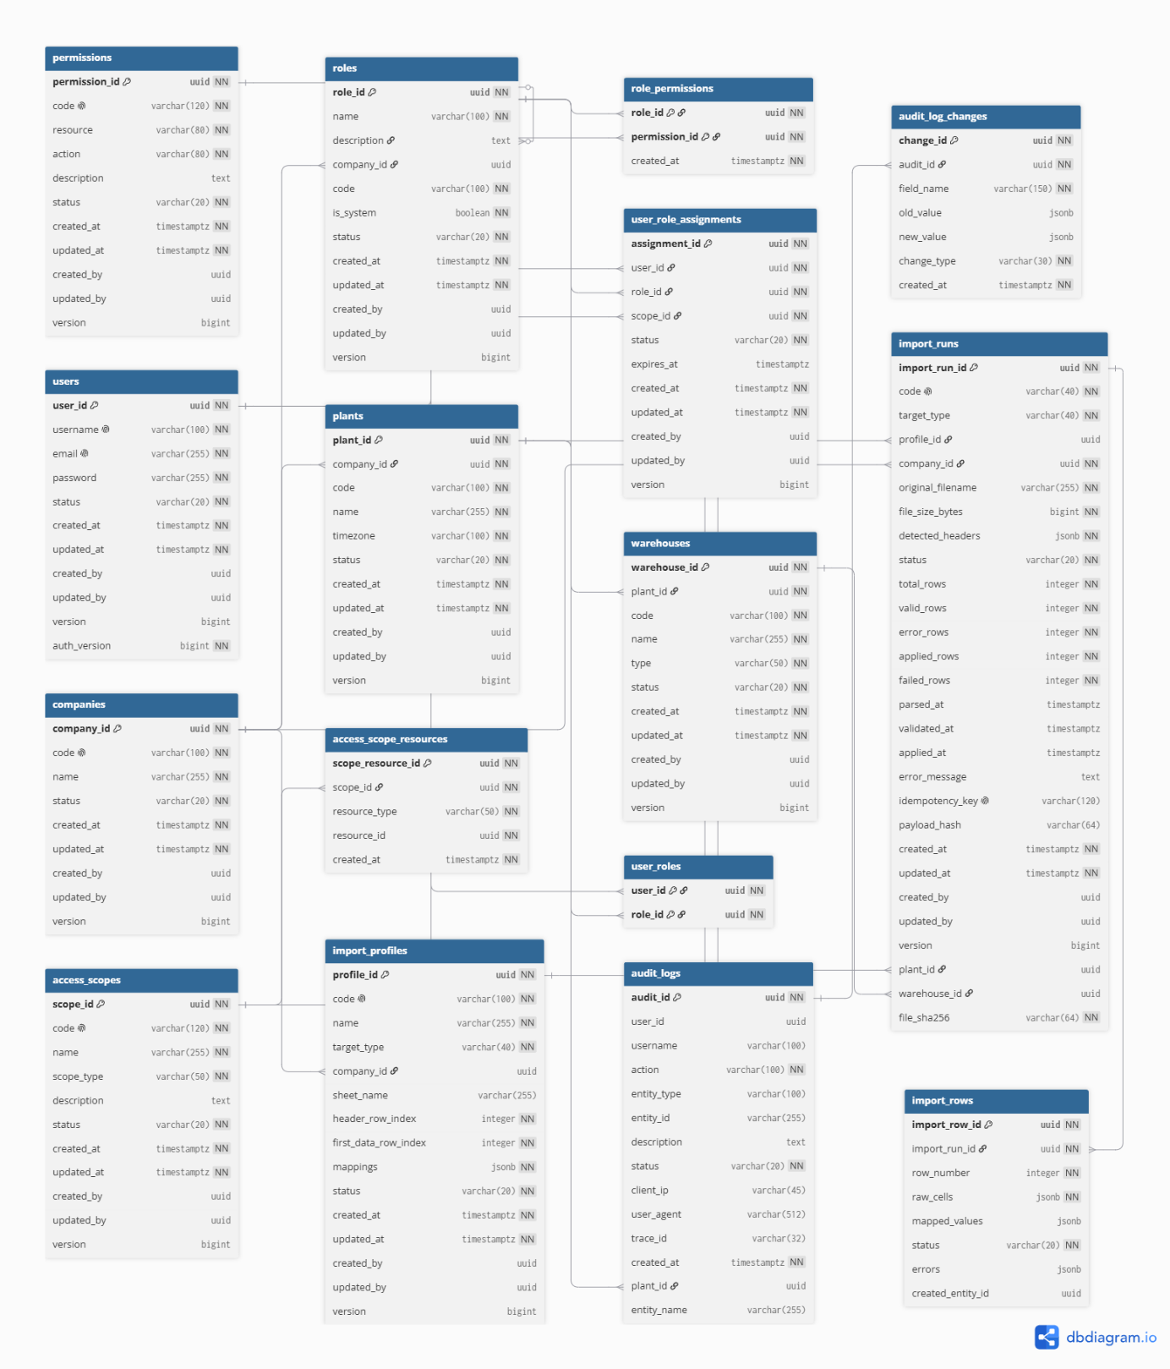
Figure 4. ERD of the System Administration and Integration module.
A Company contains multiple Plants, and each Plant contains multiple Warehouses. Roles are connected to permissions through role_permissions. A user receives operational authority through user_role_assignments, which connects a user, role, and access scope.
The audit structure separates the main audit event from its field-level changes. Data import belongs to this module because it supports controlled integration rather than representing a standalone manufacturing process.

Product and Production Master Data ERD
This module contains the reusable definitions required before planning or production can begin. It includes units of measure, Items, Bills of Materials, Routings, Routing operations, Work Centers, shifts, work calendars, and standard costs.
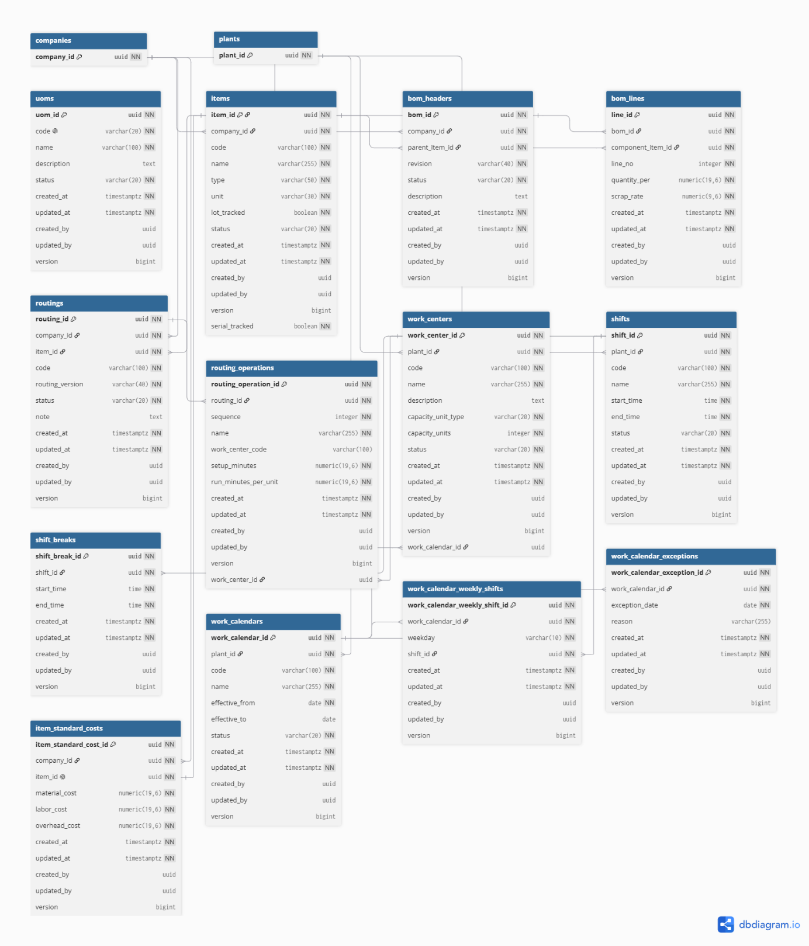
Figure 5. ERD of the Product and Production Master Data module.
An Item belongs to a Company and may be used as either a BOM parent or component. A BOM header identifies the manufactured parent Item and revision, while BOM lines define the component Items and their required quantities.
A Routing belongs to an Item and contains ordered Routing operations. Operations may reference Work Centers, while Work Centers may use work calendars composed of weekly shifts and date-specific exceptions. These relationships provide the production structure later snapshotted into Work Orders.

Sales and Planning ERD
The Sales and Planning module connects customer demand with material requirements. It includes Sales Orders, Sales Order lines, planning demands, MRP runs, run-demand snapshots, requirement lines, and supply suggestions.
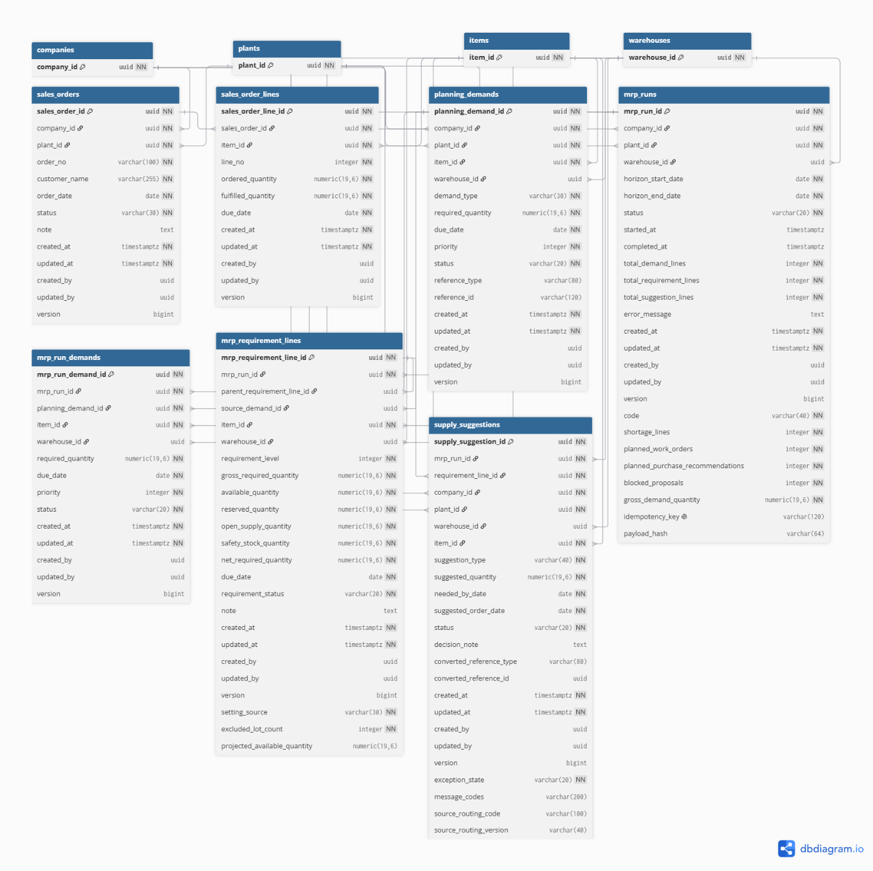
Figure 6. ERD of the Sales and Planning module.
A Sales Order contains one or more Sales Order lines. Confirmed lines generate planning demand, while an MRP run captures an immutable demand snapshot through mrp_run_demands.
Requirement lines may form a hierarchy through parent_requirement_line_id, representing multi-level BOM explosion. A shortage requirement produces a supply suggestion that may recommend either purchasing or internal manufacturing.

Purchasing ERD (Designed Only and Deferred)
This ERD documents the future external-supply architecture rather than a Capstone Project 2 implementation result. It proposes suppliers, supplier-specific Item data, Purchase Requisitions, Purchase Orders, Goods Receipts and their lines. The Purchasing extension described in Chapter 5 defines the next delivery boundary.
DESIGNED ONLY - Purchasing ERD; not delivered or accepted in Capstone Project 2.
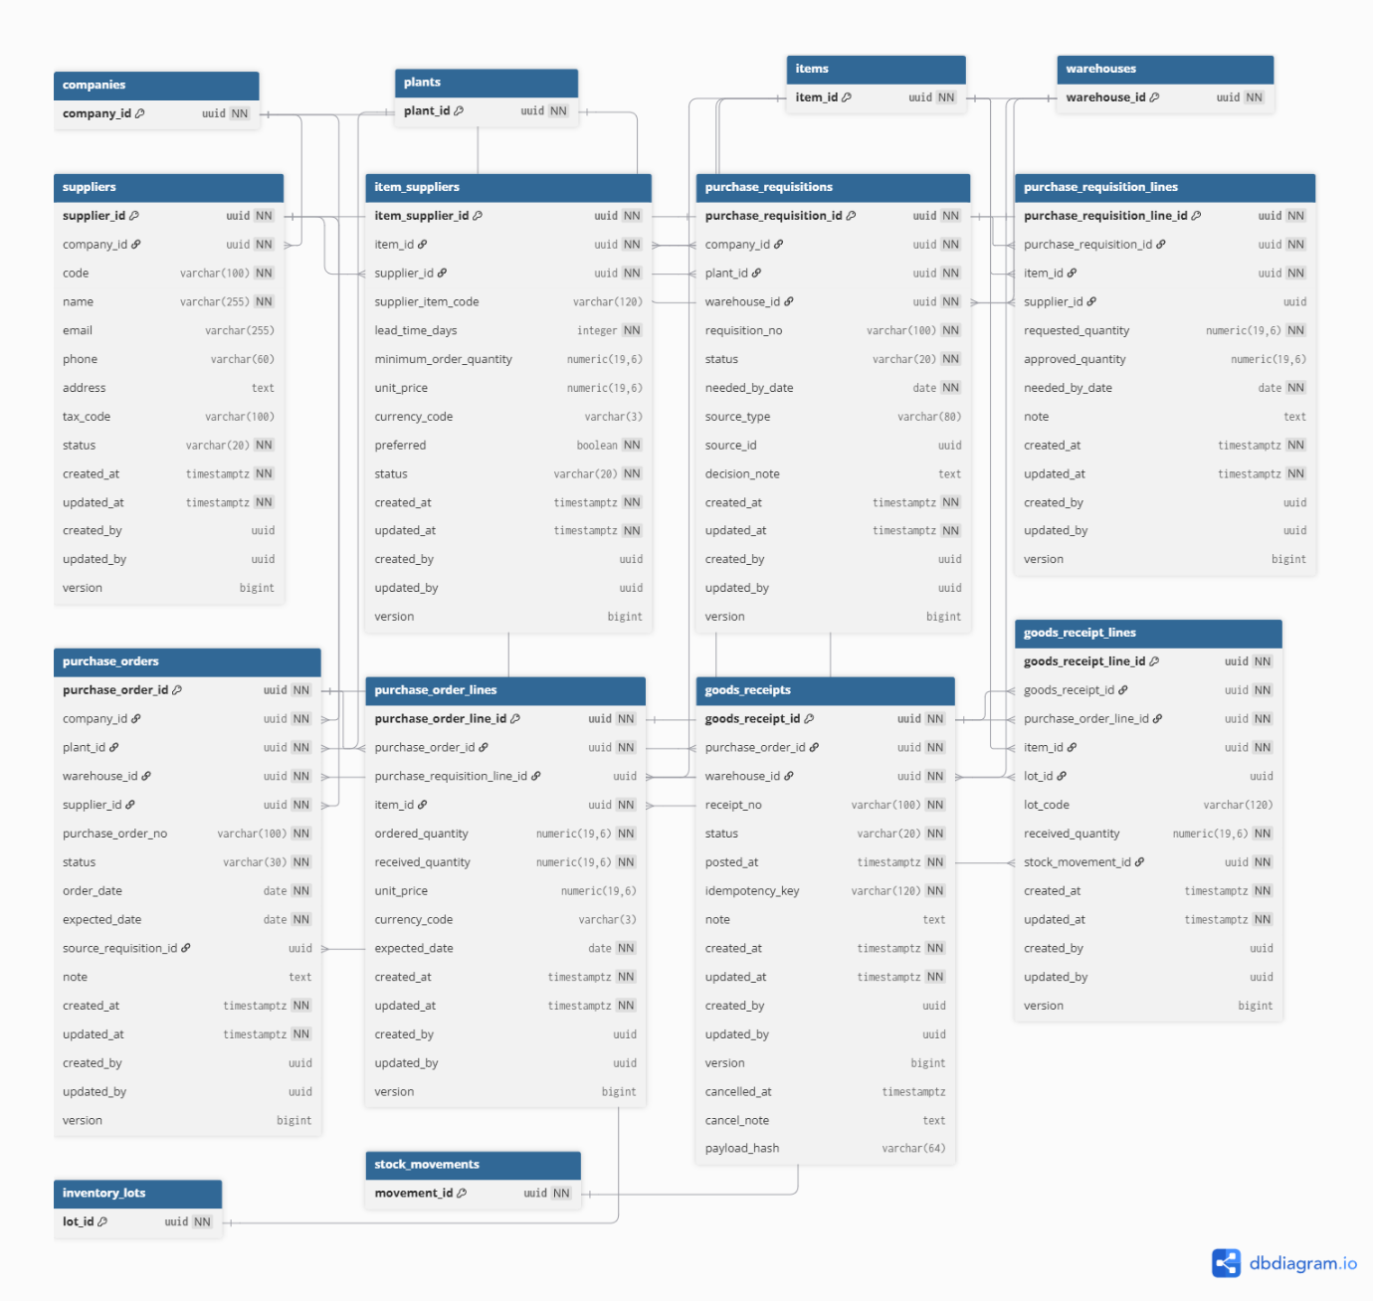
Figure 7. Purchasing ERD (designed only; deferred from Capstone Project 2).
In this deferred model, item_suppliers would establish Item/Supplier sourcing attributes such as lead time, minimum quantity, price, currency and preferred-supplier status.
The proposed relationships connect requisition lines to Purchase Order lines, and Goods Receipt lines to their order line and stock movement. These relationships describe the intended design; the corresponding functionality is not delivered in Capstone Project 2.

Inventory and Warehouse ERD
This module manages item tracking policies, planning settings, inventory balances, lots, serial numbers, and append-only stock movements.
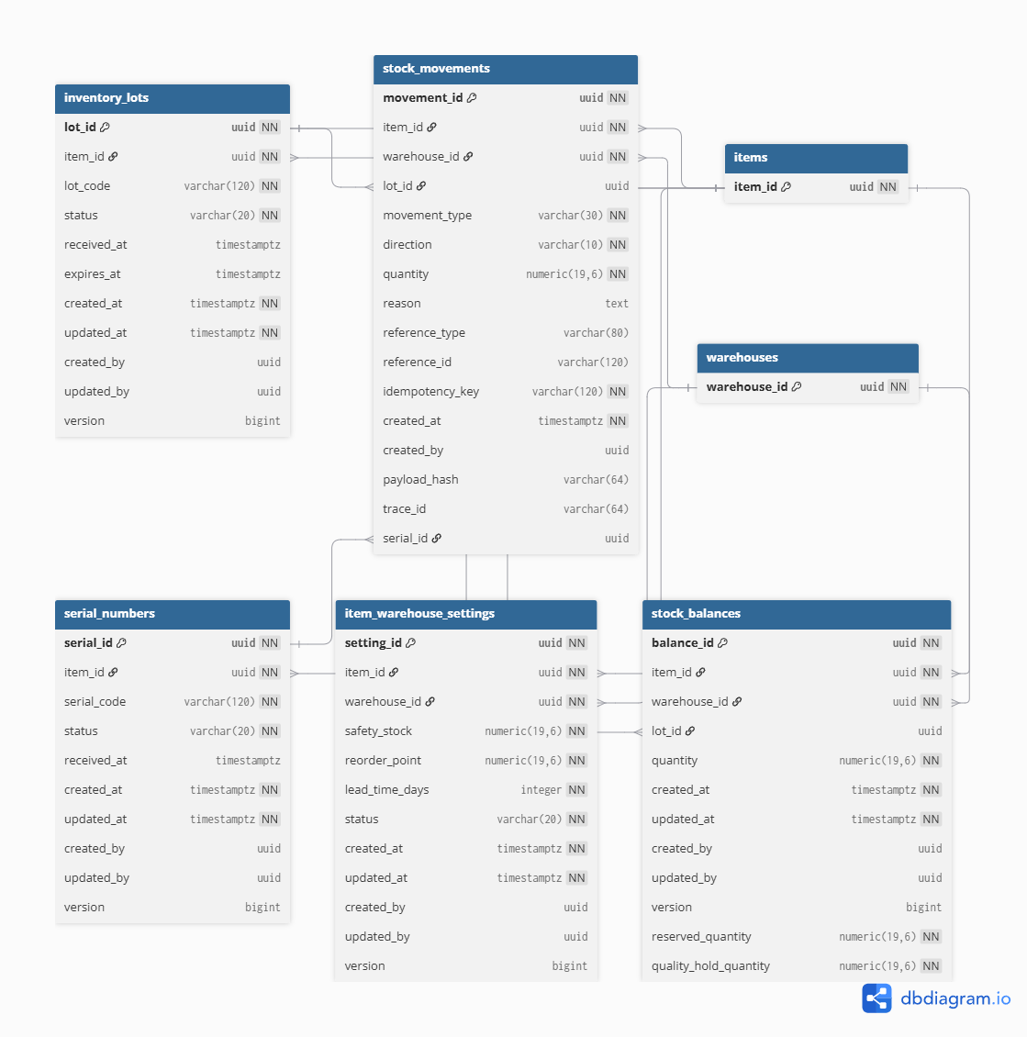
Figure 8. ERD of the Inventory and Warehouse module.
Inventory is identified by Item, Warehouse, and optional lot or serial information. stock_balances provides query-optimized on-hand, reserved, and quality-hold quantities. stock_movements preserves the immutable history of receive, issue, adjustment, reversal, and lot-status transactions.
Item-Warehouse settings store safety stock, reorder point, and lead-time configuration used by planning and operational alerts. Lot and serial statuses determine whether a quantity is eligible for reservation, issue, MRP, or fulfillment.

Manufacturing Execution and Quality ERD
This module records the internal production lifecycle from Work Order creation through material consumption, WIP reporting, finished-goods receipt, and quality disposition.
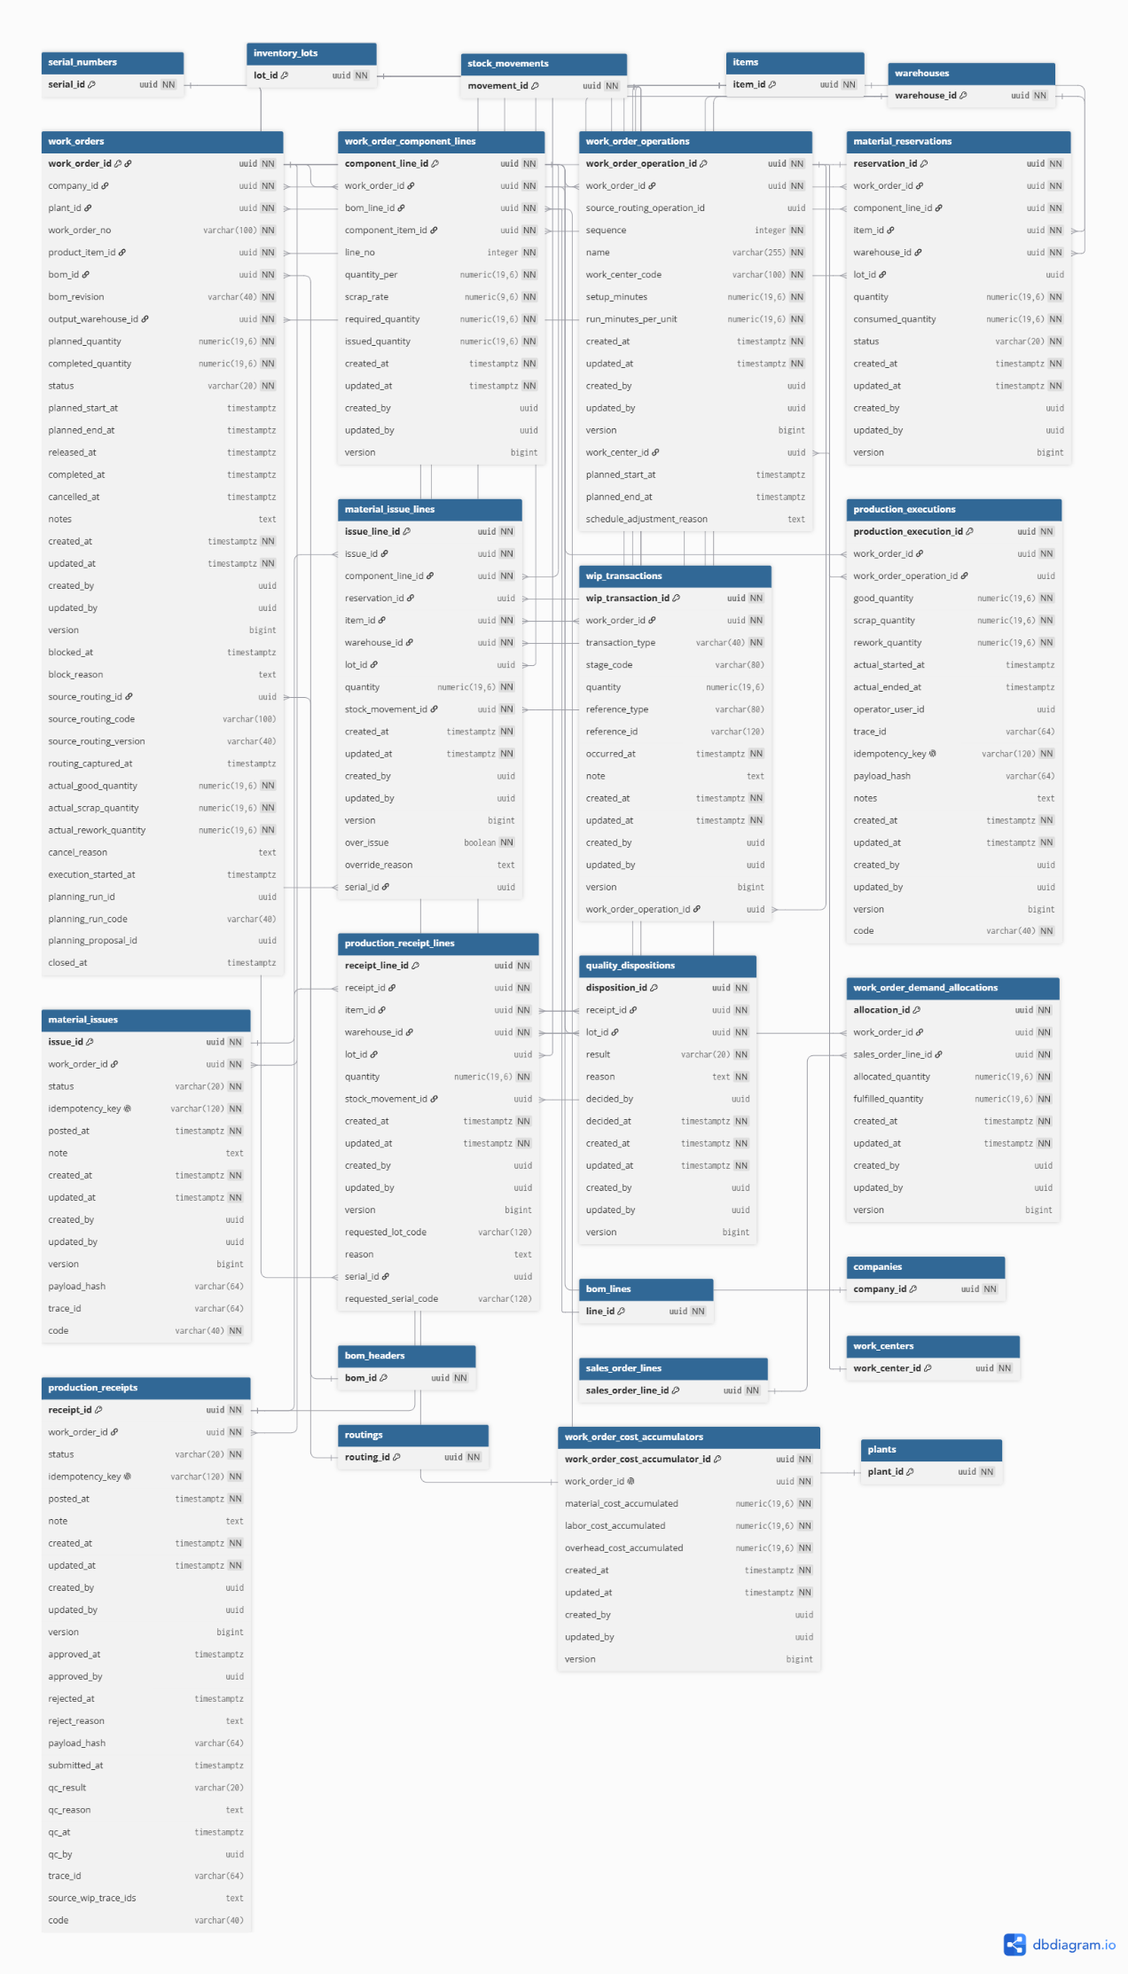
Figure 9. ERD of the Manufacturing Execution and Quality module.
A Work Order contains immutable component and operation snapshots. Material reservations connect component requirements with eligible Warehouse and lot stock. Material Issues consume those reservations and connect each issue line to its inventory movement.
WIP transactions and Production Executions preserve actual manufacturing evidence. Production Receipt lines connect output Items, Warehouses, lots or serials, and stock movements. Quality dispositions are stored separately so receipt approval and final quality acceptance remain distinct decisions.

Cross-Module Data Relationships
The diagrams document the integrated data model. Purchasing relationships are retained as future design references, while the current production loop connects demand, Work Orders, issue, receipt, QC and inventory.
Relationship chain | Purpose
Company -> Plant -> Warehouse | Establishes organizational ownership and authorization scope.
Item -> BOM / Routing / Inventory / Purchasing (deferred) | Connects product definition with planning, sourcing, and stock.
Sales Order Line -> Planning Demand -> MRP Run | Preserves the origin of demand entering material planning.
MRP Requirement -> Supply Suggestion | Records shortage analysis and the recommended BUY or MAKE response.
Purchase Order -> Goods Receipt -> Stock Movement (deferred) | Future design relationship for supplier delivery and the inventory ledger; not delivered in Capstone Project 2.
Work Order -> Material Issue -> Stock Movement | Connects production consumption with inventory.
Work Order -> Production Receipt -> Quality Disposition | Connects manufactured output with approval and QC status.
Work Order Allocation -> Sales Order Line | Connects quality-approved output back to customer demand.
Table 5. Cross-module data relationships.

Business Rules and State Controls
OmniPlant applies validation at both the document and inventory levels. The principal rules are summarized in the following table.
Rule | Current contract or explicit future rule
Quantity | Transactional, Sales Order, and production quantities must be greater than zero.
Lot eligibility | HOLD, REJECTED, and expired lots are excluded from availability, reservation, MRP, and fulfillment.
Demand | Only confirmed and open demand participates in planning and allocation.
Snapshot | Work Orders retain immutable BOM and Routing evidence.
Release | Current policy - FULL_KIT: fully reserve every BOM-snapshot component before release. This simplifies readiness and prevents known shortages in manual execution; it is not a universal rule. Progressive/operation-level staging is deferred.
Issue | Only a posted Material Issue decreases inventory; over-BOM issue requires reason and permission.
Receipt | Submission has no inventory effect; only approval creates finished-goods inventory.
Quality | Approved output remains on HOLD until disposition; only AVAILABLE output satisfies demand.
Retry safety | Commands that change data require explicit confirmation, and a retry of the same logical request reuses the same request key so that it cannot create a second effect.
Separation of duties (current) | An Operator without approval permission cannot approve a submitted receipt. A Manager holding both permissions can currently approve a receipt and also decide its quality outcome.
Separation of duties (proposed) | For configured high-risk receipts, the person deciding the quality outcome would be required to differ from the person who approved the receipt. This is proposed and is not currently enforced.
Table 6. Core business validation rules.

API, Security, and Transaction Resilience
Every backend response uses a standard envelope containing a response code, message, and optional result. Paginated endpoints additionally return page, size, total element, and total-page information.
Authentication uses JWT access tokens together with rotating refresh tokens. After authentication, the client loads the authoritative user profile, permissions, role assignments, and access scopes. The frontend uses this information to control navigation and action visibility, while the backend performs the final authorization check for every protected operation.
Authorization combines permissions with organizational scope. A user may have permission to manage Work Orders but remain limited to a specific Plant. Requests outside the assigned scope are rejected even when the general permission is present.
The frontend reuses a stable request key when it retries the same logical request. The backend stores that key with the document it creates, so a repeated request returns the original document instead of producing a second one, and the same key submitted with different content is refused as a conflict. Purchasing Goods Receipt remains a deferred target rather than current behaviour.
Commands that change inventory are applied inside a single database transaction, so that a failure at any point leaves no partial effect: an approval that fails part-way creates no lot, no movement, no balance change and no fulfillment update. Concurrent access to the same stock balance is controlled at the database level, so that two Work Orders reserving from the same quantity cannot together reserve more than is on hand. These properties follow from the transaction and locking design; the evidence obtained for them is reported in Section 4.3.

Frontend Interaction Design
The frontend is designed primarily for desktop and tablet operation. Dense lists, filters, status indicators, and forms follow a consistent ERP interaction model.
Loading states use Skeleton placeholders. Empty states explain why no records are available and display creation actions only when the user has permission. Validation and API errors preserve entered values so the user can correct or retry a request without re-entering the entire form.
Critical state changes require explicit confirmation. These actions include Sales Order confirmation, BOM and Routing activation, Work Order release, Material Issue posting, receipt approval or rejection, and quality disposition.
All user-visible content is maintained in English and Vietnamese translation namespaces. Status labels and validation messages use consistent terminology across list, detail, and transaction screens.

System Operation and Deployment
A standard local environment consists of PostgreSQL, Redis, the Spring Boot backend, and the Next.js frontend. PostgreSQL migrations are managed through Flyway. The backend normally runs on port 8080, while the frontend runs on port 3000.
After the infrastructure has started, the operator confirms authentication, roles and scopes, Plant selection, API health and completed migrations. The end-to-end walkthrough then follows demand, planning, MAKE conversion, production, inventory posting, separate approval and quality disposition, and audit review. Purchasing execution lies outside this workflow.
Operational step | Expected check
1. Start infrastructure | PostgreSQL and Redis are healthy and Flyway migrations are complete.
2. Start API | Actuator health reports UP and OpenAPI is reachable.
3. Start frontend | The application loads correctly and unauthenticated users are redirected to the Login page.
4. Authenticate | Profile, permissions, scopes, and default Plant are loaded.
5. Select Plant | Queries refetch without displaying stale data from another Plant.
6. Execute workflow | Confirmation and idempotent commands are used and document status is verified after each transition.
7. Verify results | Movements, lot status, Dashboard, Sales Order fulfillment, and audit evidence are checked.
Table 7. Operational startup and verification checklist.

Chapter Summary
This chapter presented the architectural, functional, process, and data design of OmniPlant. The use case diagram defined the responsibilities of Administrator, Manager, and Operator, while the role-labelled process diagram described the execution sequence and automated System behavior.
The six ERDs describe related domains with explicit links. Purchasing is retained as designed-only future architecture. The implemented traceability path runs from access and confirmed demand through material planning, production, inventory posting and quality-controlled output; it does not demonstrate delivered Purchasing execution.

RESULTS AND DISCUSSION

Implementation Results
Capstone Project 2 completed the focused ERP production loop from confirmed Sales Order demand to QC-approved AVAILABLE inventory. The implementation is no longer a high-fidelity prototype: the primary MVP routes use backend APIs, UUID identifiers, decimal-safe adapters, permission-aware React Query hooks and documented invalidation across related modules.
Area | Delivered behavior | Status
Planning | Confirmed demand -> immutable run -> requirements/netting -> MAKE/BUY suggestions | Feature-complete and API integrated; backend acceptance pending (Section 4.3)
Work Order | Conversion/manual draft, plan, snapshots, readiness, reservation, release, cancel/close | Feature-complete and API integrated; backend acceptance pending (Section 4.3)
Material Issue | Reservation-backed and eligible-stock issue, stock movement, trace and variance seam | Feature-complete and live write accepted; backend acceptance pending (Section 4.3)
Manual Execution | Good/scrap/rework, actual time, notes and WIP history | Feature-complete and API integrated; backend acceptance pending (Section 4.3)
Production Receipt | Partial receipt, submit, approve/reject, HOLD and QC disposition | Feature-complete and API integrated; backend acceptance pending (Section 4.3)
Inventory/Dashboard | Balances, lots, movements, availability exclusion, alerts and recent activity | Feature-complete and live accepted; backend acceptance pending (Section 4.3)
Admin/RBAC | Users, roles, permissions, scopes and assignments | Feature-complete for current three-actor model; backend acceptance pending (Section 4.3)
Table 8. Capstone Project 2 delivery summary

API-Backed Interface Evidence
The following subsections present the current OmniPlant interface screenshots embedded in the Capstone Project 2 presentation. Each subsection documents one screen, its operational purpose and the evidence visible in the refreshed demonstration dataset.

Dashboard Overview
This screen gives managers an API-backed summary of current inventory and manufacturing activity. It highlights operational alerts and recent movements so exceptions can be identified quickly.
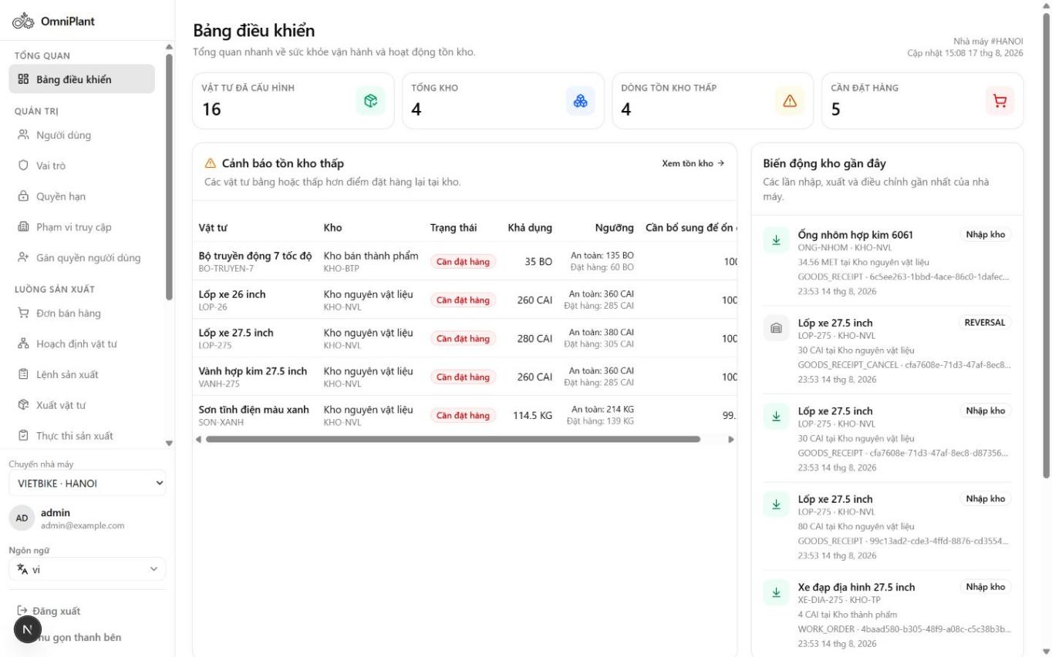
Figure 10. Dashboard with API-backed operational overview and alerts

Item Master
This screen maintains the core item records used across inventory, BOM and production processes. It shows item type, unit of measure and tracking policy to ensure consistent downstream transactions.
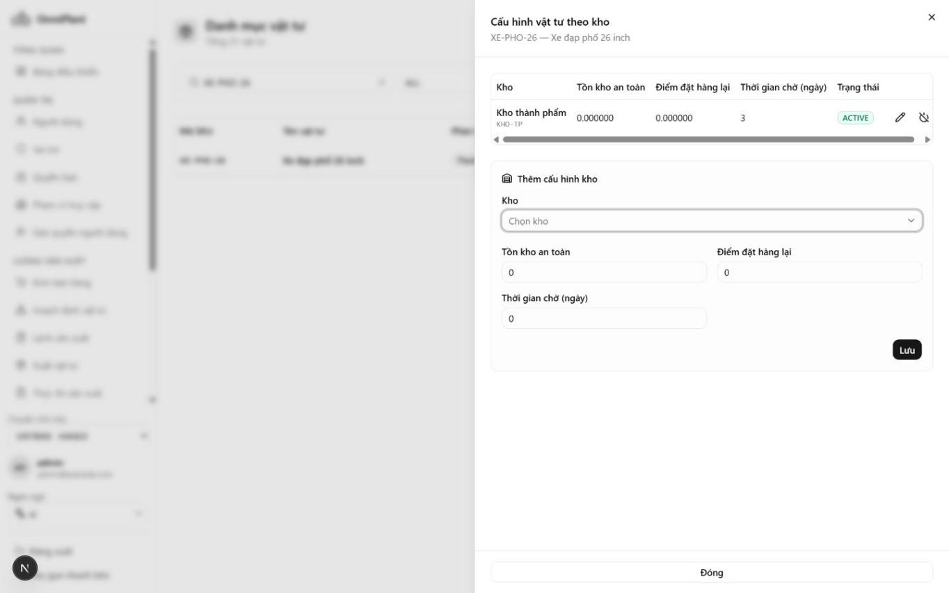
Figure 11. Item Master with item types, UOM and tracking-policy evidence

Stock Balance
This screen presents inventory quantities by item and storage location. On-hand, reserved and available balances are separated so users can evaluate usable stock accurately.
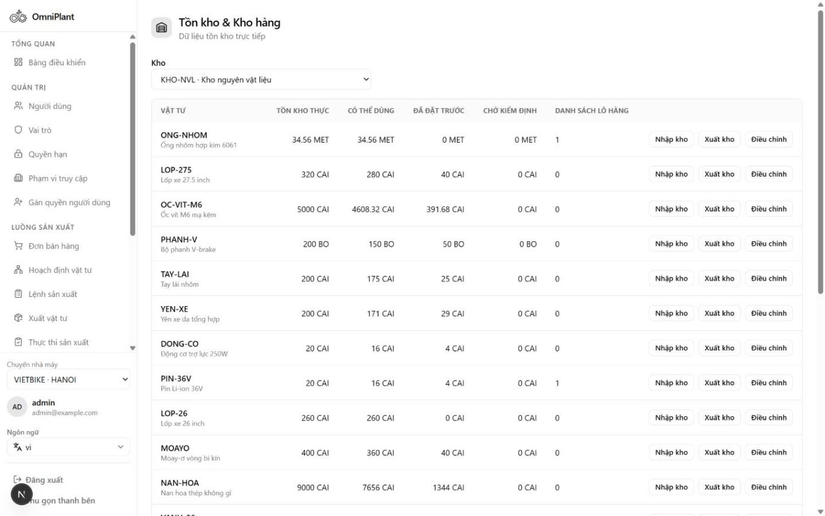
Figure 12. Stock Balance with on-hand, reserved and available quantities

Inventory Lots
This screen provides lot-level inventory visibility for traceable materials and products. Status values such as AVAILABLE, HOLD and REJECTED make quality eligibility clear before planning or issue.
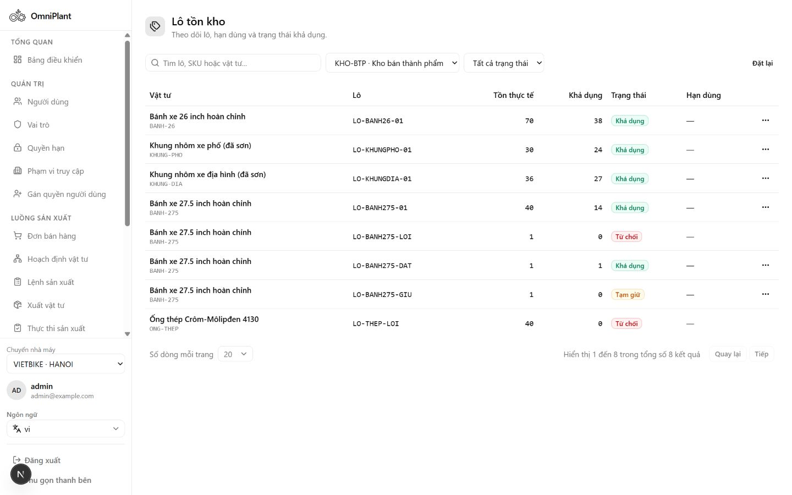
Figure 13. Inventory Lots with AVAILABLE, HOLD and REJECTED status evidence

Stock Movement History
This screen records the append-only history of inventory transactions. Movement types and trace references help users audit how stock quantities changed over time.
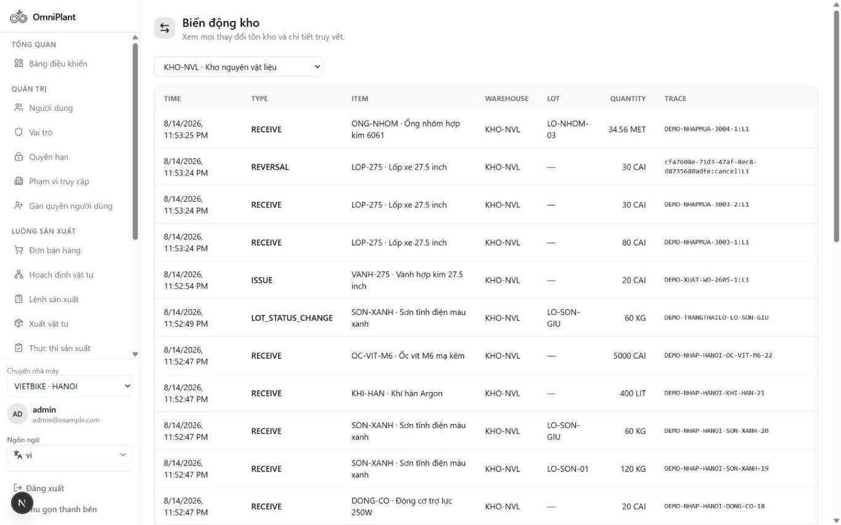
Figure 14. Stock Movement history with transaction types and trace references

BOM List
This screen lists Bills of Materials and their lifecycle states. Users can distinguish active production definitions from drafts before selecting a structure for planning or execution.
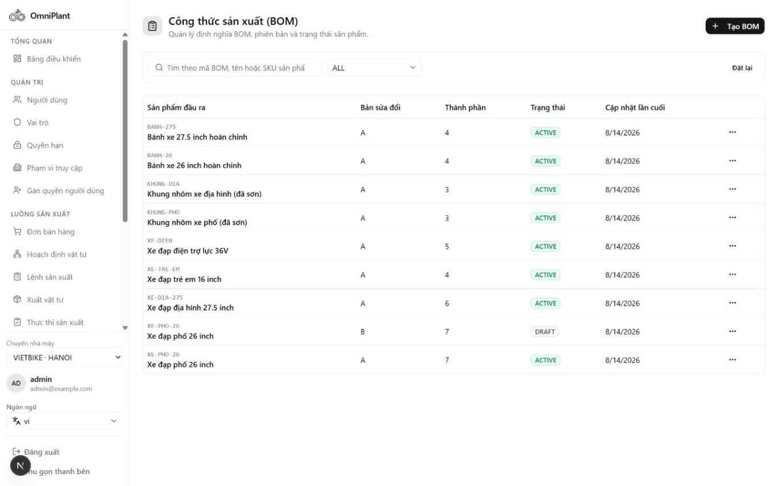
Figure 15. BOM list with active and draft lifecycle visibility

Active BOM Detail
This screen displays the approved product structure for a manufactured item. Revision, output quantity and component lines define the material basis used by planning and Work Orders.
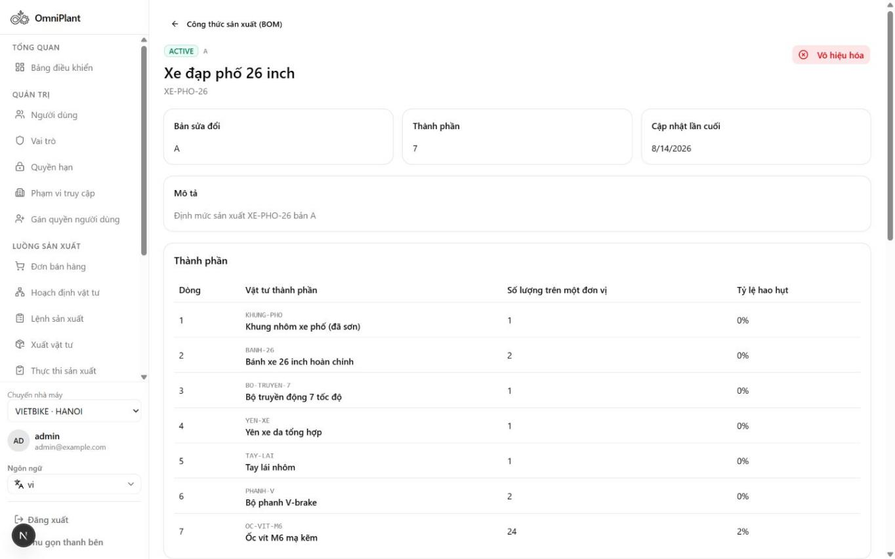
Figure 16. Active BOM detail with revision, output quantity and component lines

Multi-Level BOM Tree
This screen visualizes nested assemblies and components across multiple BOM levels. The hierarchy helps users understand dependent quantities and the full material composition of the finished product.
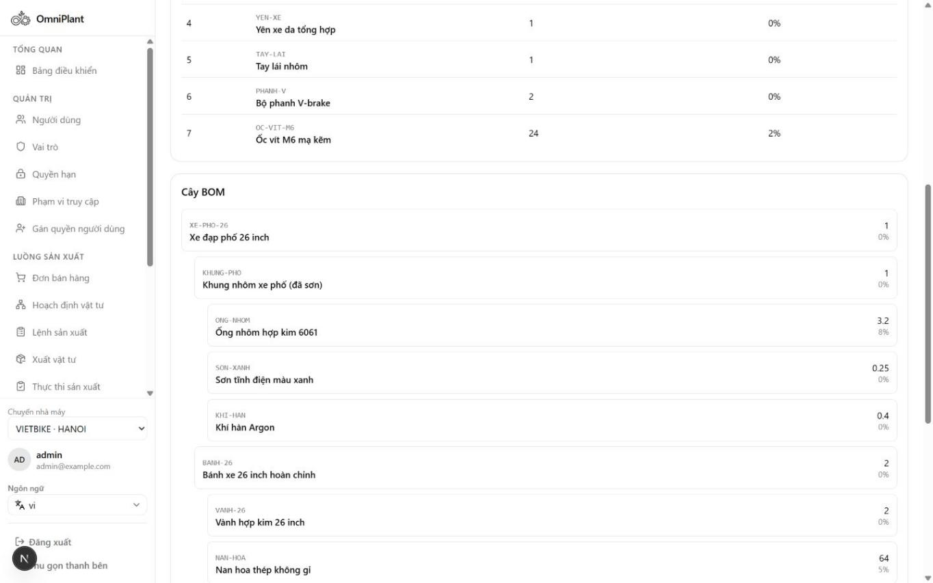
Figure 17. Multi-level BOM tree showing nested sub-assemblies and component quantities

Sales Order List
This screen summarizes customer demand and its document lifecycle. Order and fulfillment statuses allow managers to identify confirmed demand that is ready for material planning.
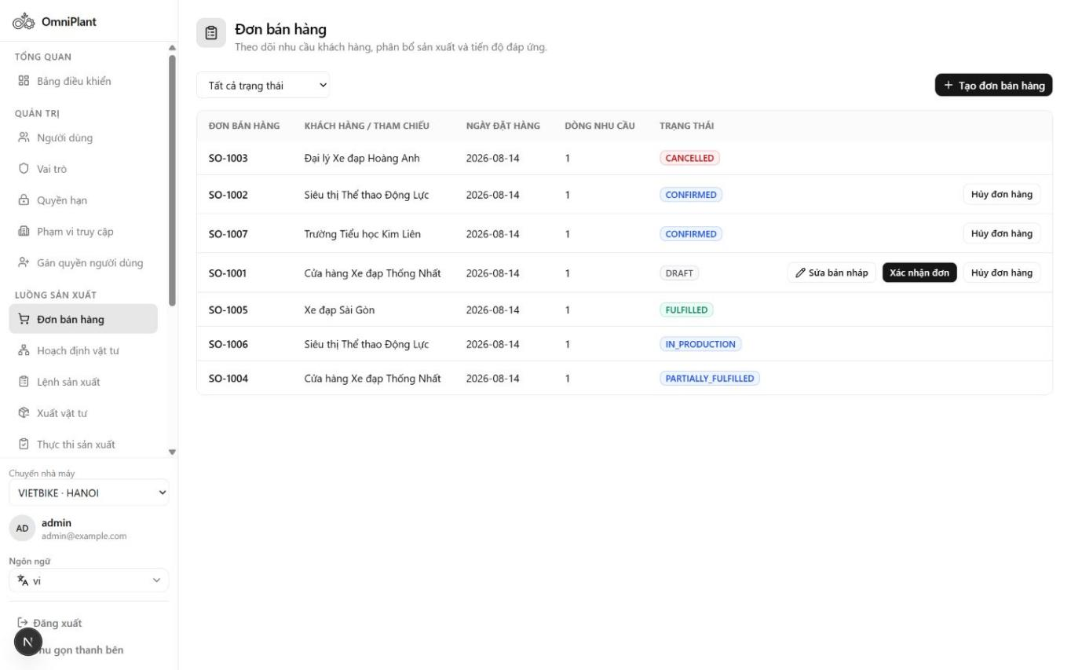
Figure 18. Sales Order list with lifecycle and fulfillment status evidence

Sales Order Detail
This screen shows the selected order, its line items and requested quantities. Allocation and fulfillment values connect customer demand with later planning and production results.
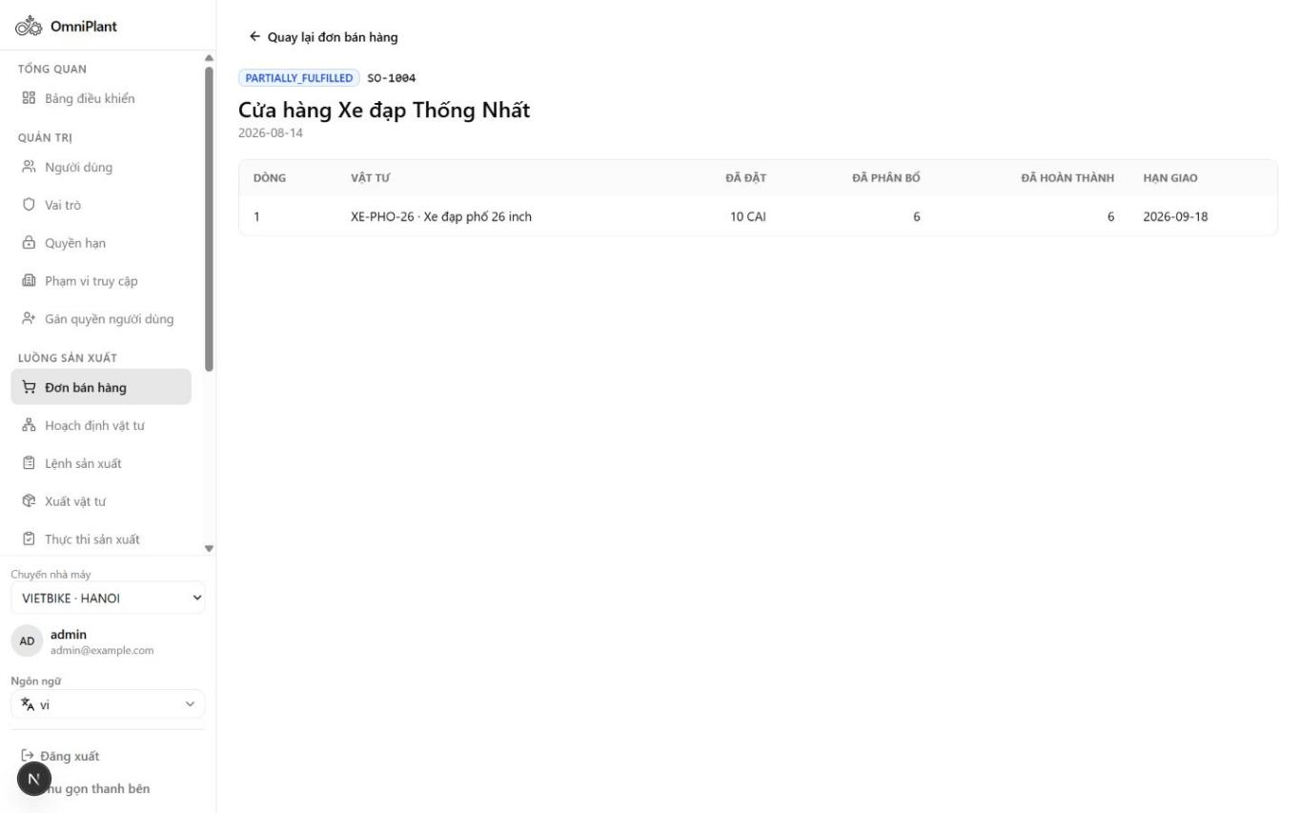
Figure 19. Sales Order detail with line allocation and fulfillment quantities

Material Planning Workspace
This screen is the entry point for converting confirmed demand into an MRP Planning Run. It presents eligible Sales Orders and previous run history for controlled, auditable planning.
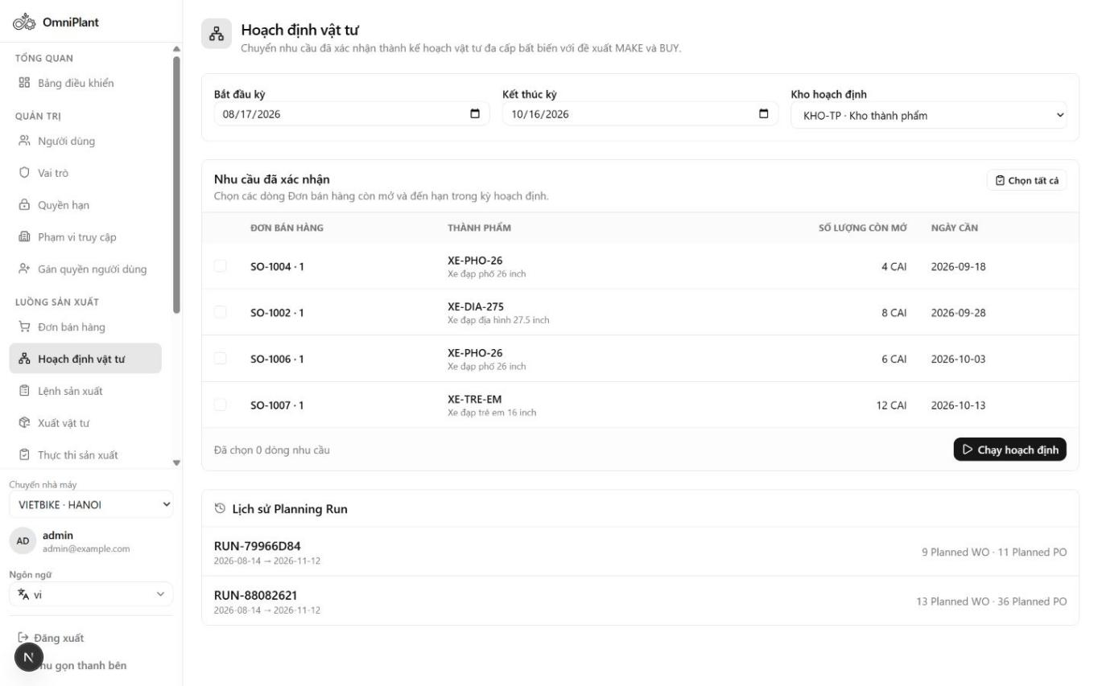
Figure 20. Material Planning workspace with confirmed demand and Planning Run history

Planning Run Detail
This screen explains the calculated material requirements for a specific immutable Planning Run. Shortages and MAKE or BUY suggestions show how available supply is compared with production demand.
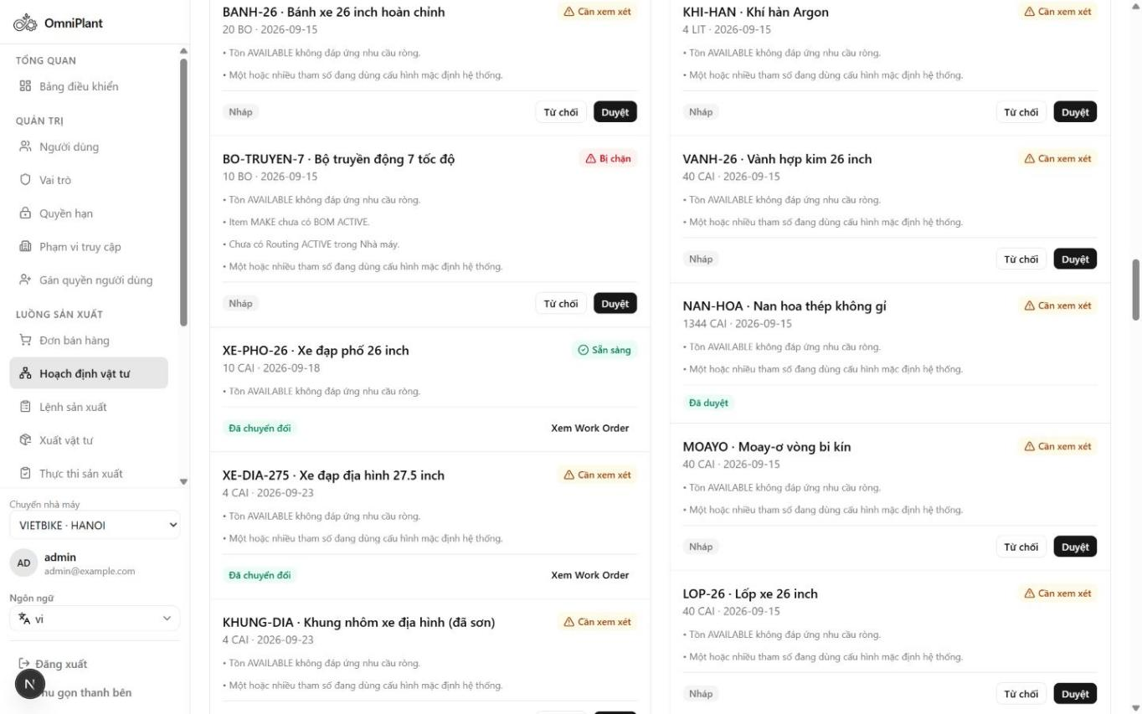
Figure 21. Planning Run detail with shortage and MAKE/BUY supply decisions

Work Order List
This screen provides an overview of manufacturing orders and their current lifecycle states. Users can monitor which orders are planned, released, in progress, blocked or completed.
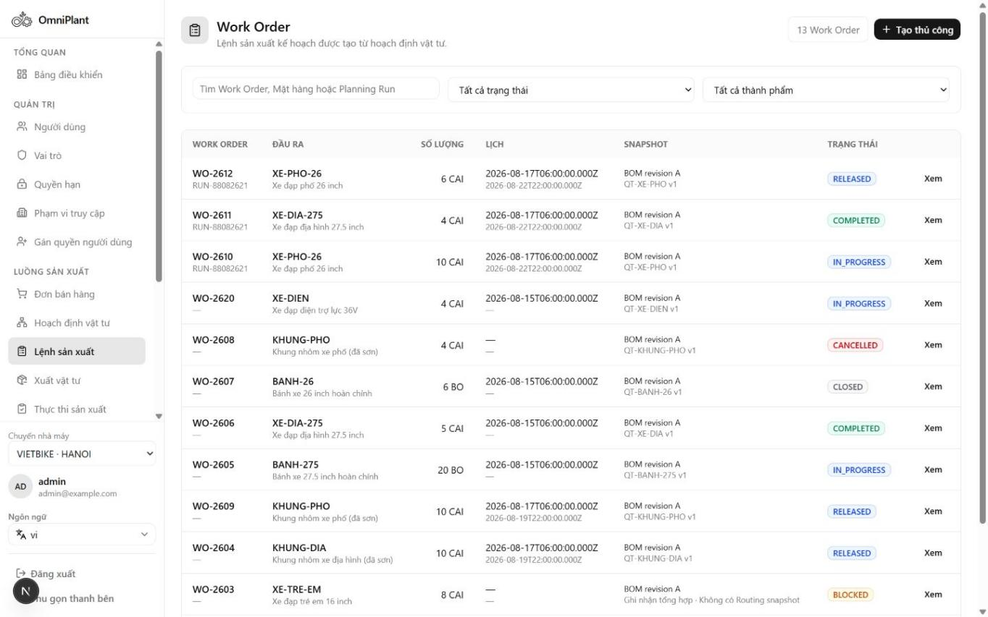
Figure 22. Work Order list with production lifecycle status evidence

Work Order Detail
This screen consolidates the production scope, snapshots and material readiness of a Work Order. Reservation status supports the decision to release the order safely for execution.
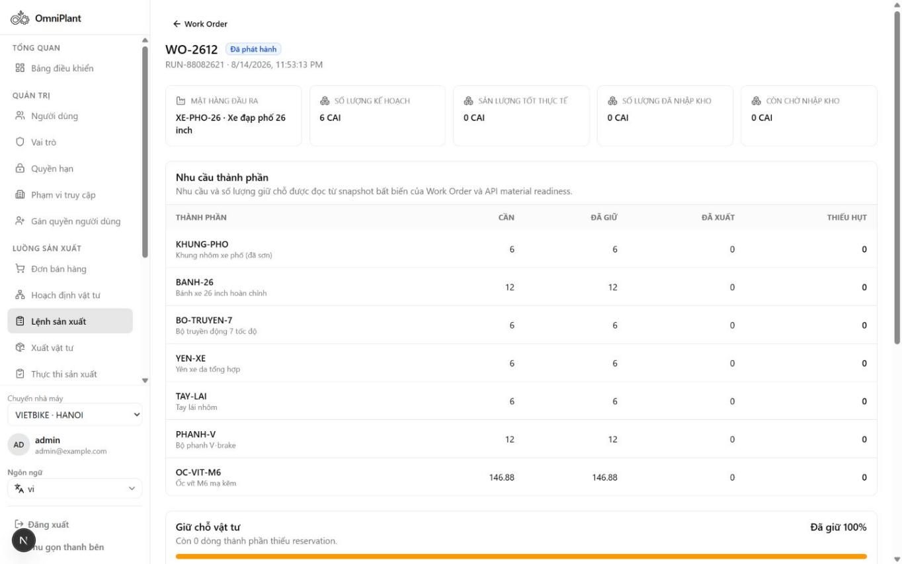
Figure 23. Work Order detail with complete reservation readiness

Material Issue Workspace
This screen supports controlled consumption of reserved components for a Work Order. Component requirements and issue history help operators verify eligible quantities and preserve inventory traceability.
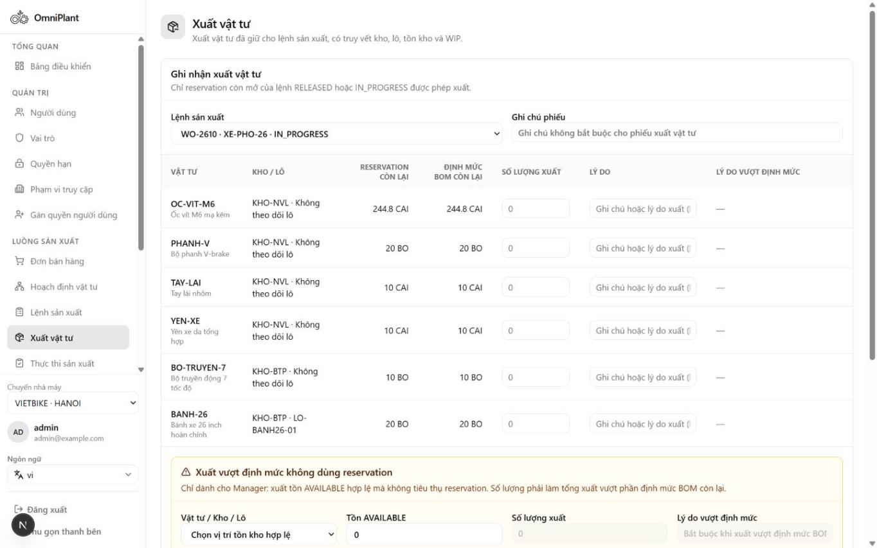
Figure 24. Material Issue workspace with component and issue-history evidence

Production Execution Workspace
This screen records manual shop-floor results without claiming MES integration. Operators capture good, scrap and rework quantities together with actual execution evidence.
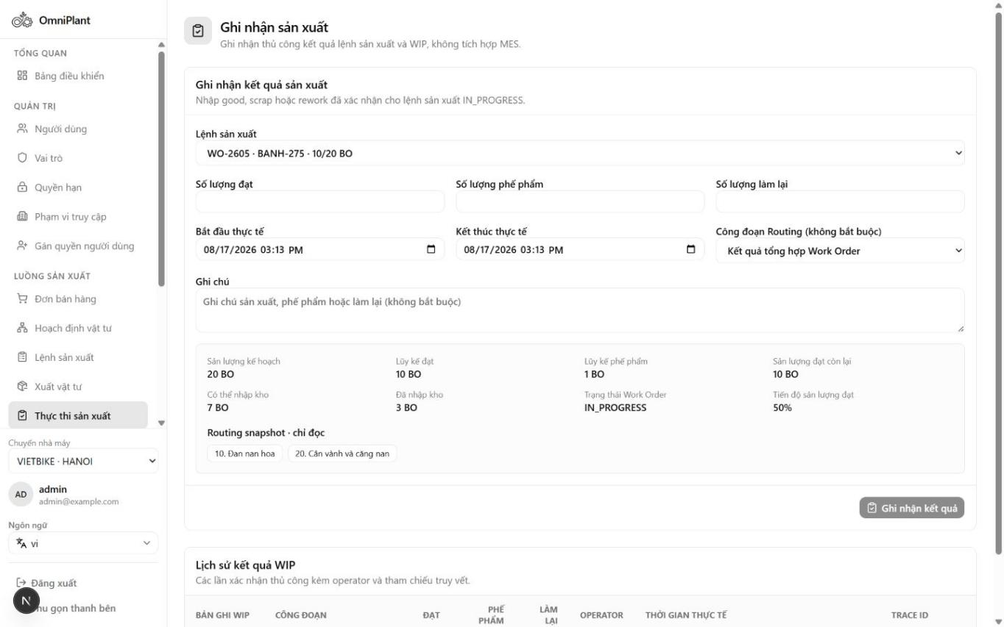
Figure 25. Production Execution workspace with good, scrap and rework quantities

Production Receipt List
This screen tracks finished-output receipt documents and their approval states. It supports the transition from reported production into HOLD inventory pending quality disposition.
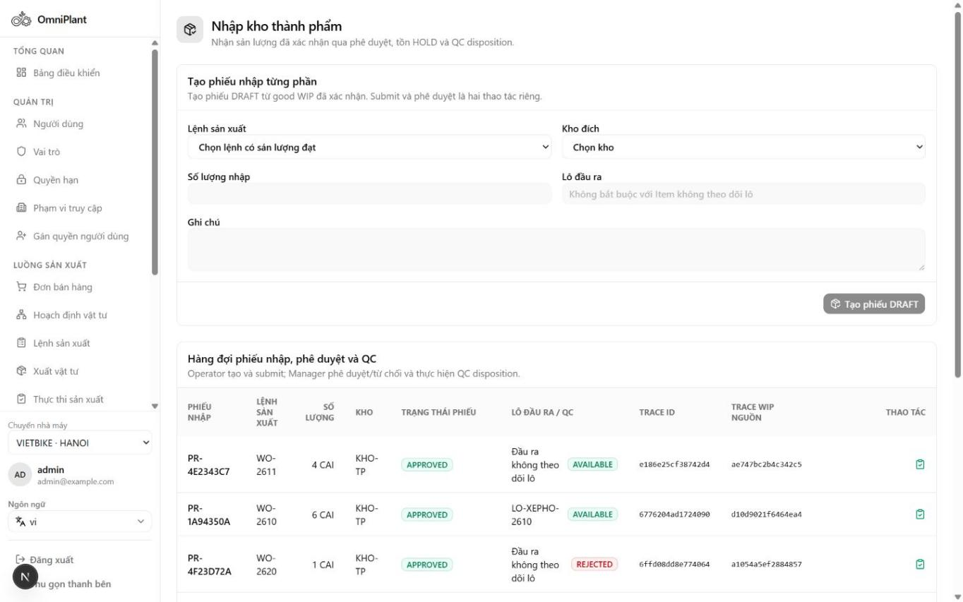
Figure 26. Production Receipt list with approval and QC lifecycle states

Inventory Lots after Quality Control
This screen shows the quality outcome of received production lots. AVAILABLE, HOLD and REJECTED statuses demonstrate which output can be used for planning or fulfillment.
Figure 27. Inventory Lots after QC with AVAILABLE, HOLD and REJECTED output

Login and Session Initialization
This screen authenticates the user and initializes the authorized operating context. Session and Plant scope are established before protected ERP functions become available.
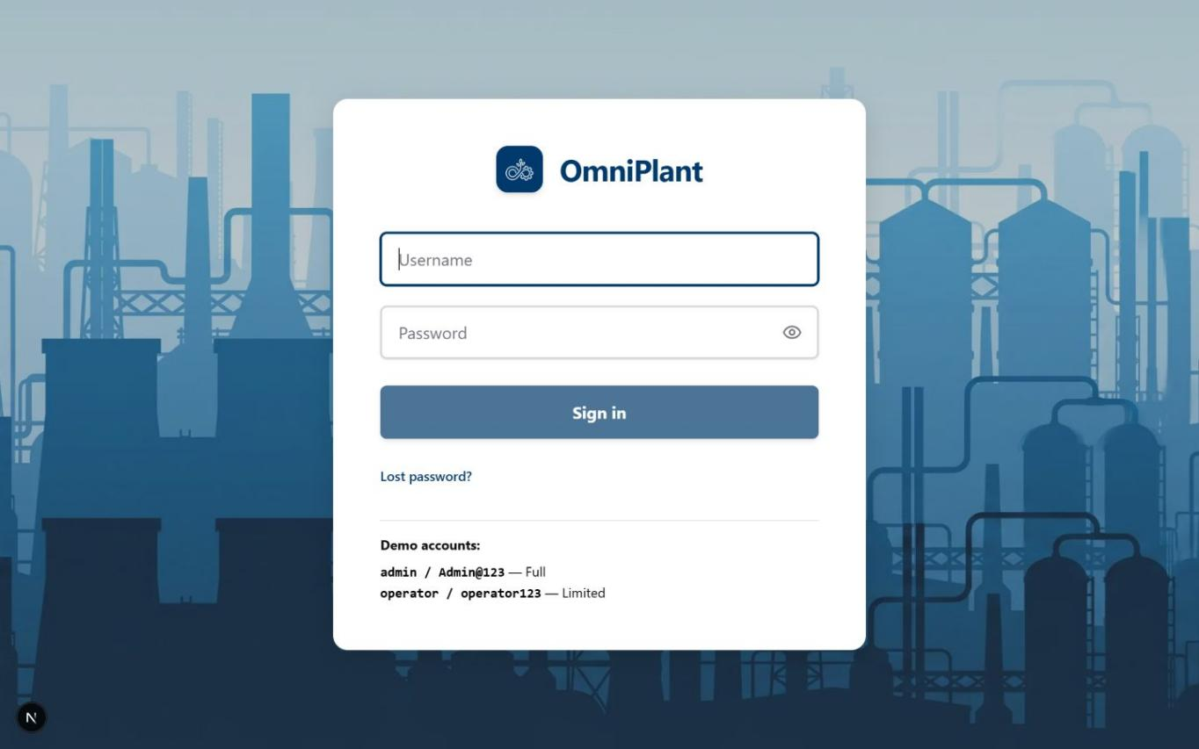
Figure 28. Login interface for session and Plant-scope initialization

User Management
This screen maintains application accounts and their lifecycle status. Administrators can review active or inactive users before assigning responsibilities and access scope.
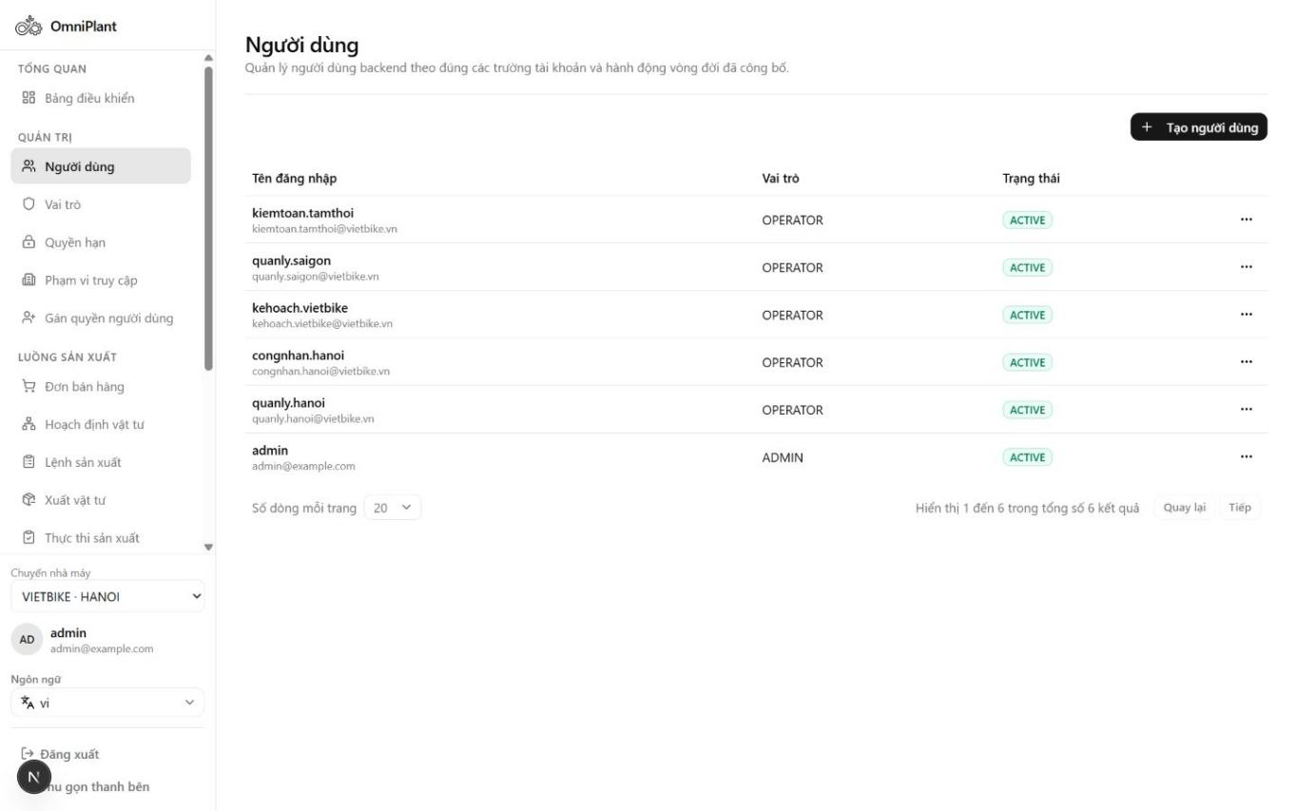
Figure 29. User management with account lifecycle status

Role Management
This screen defines the responsibility groups used by dynamic role-based access control. Active roles provide a reusable basis for assigning operational permissions to users.
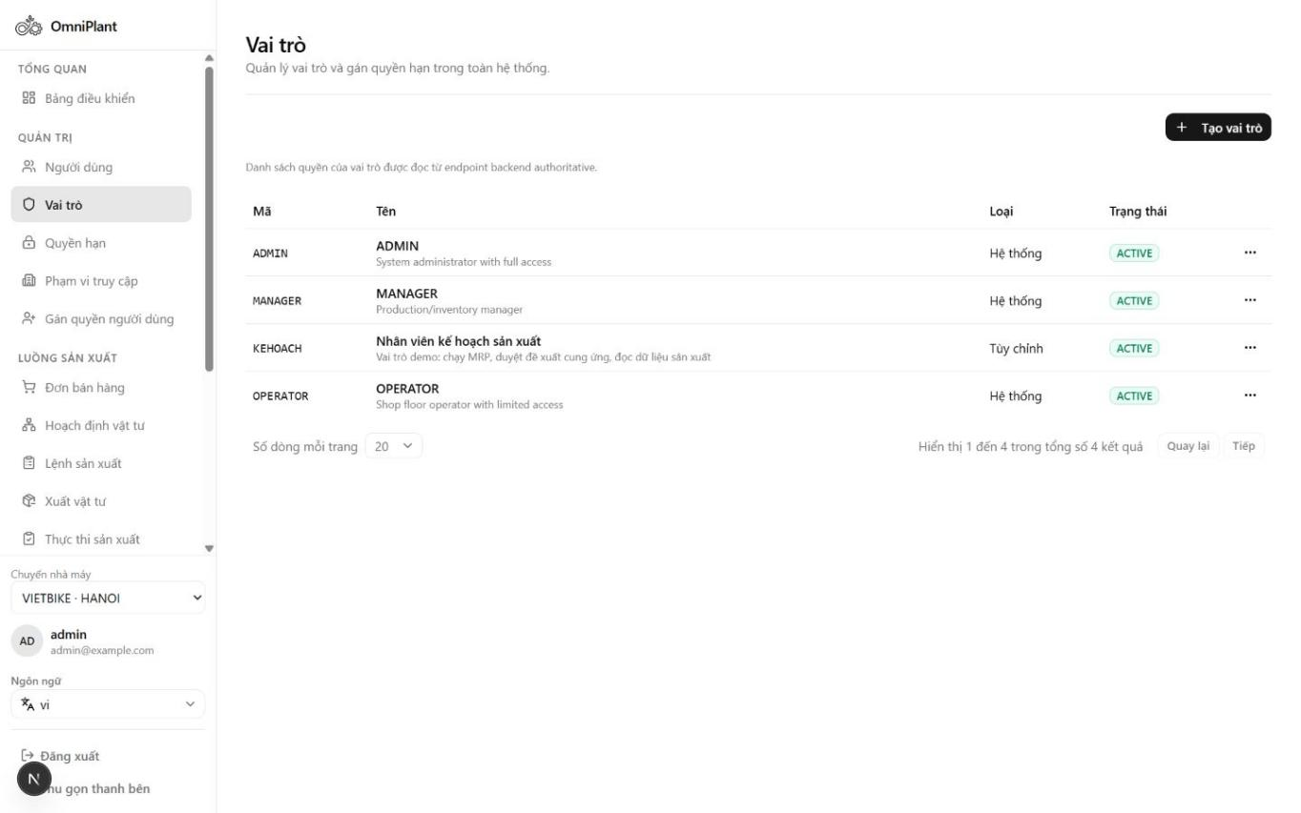
Figure 30. Role management with active responsibility groups

Permission Catalog
This screen lists the resource and action permissions recognized by the system. The catalog makes authorization rules explicit and supports consistent role configuration.
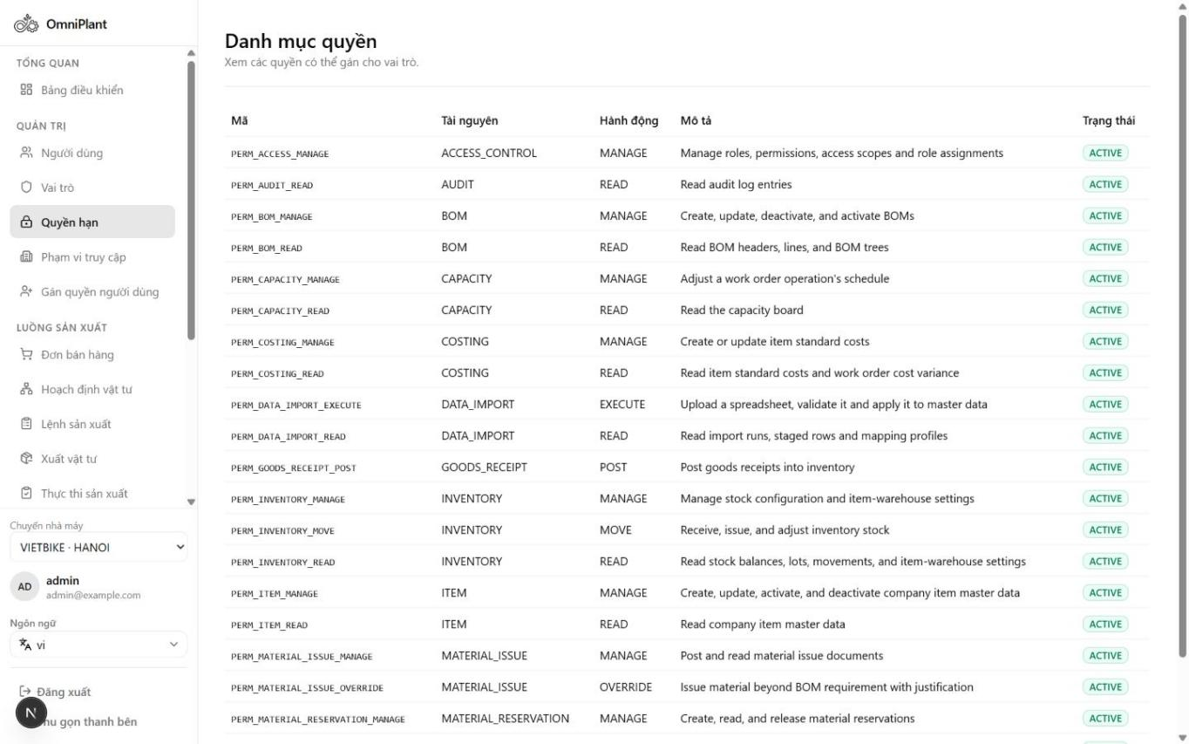
Figure 31. Permission catalog with resource and action codes

Access Scope Management
This screen defines where an assigned role is allowed to operate. Organization-level scopes restrict data and actions to the appropriate Company, Plant or Warehouse context.
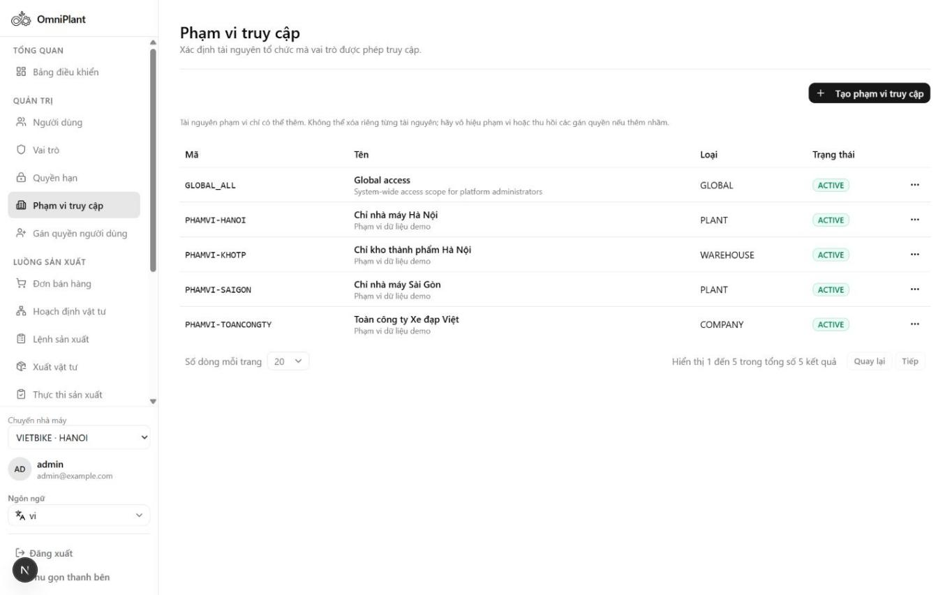
Figure 32. Access Scope management across organization levels

User Assignment
This screen links a user with a role and an access scope. The assignment form combines responsibility and organizational boundary into one authorization record.
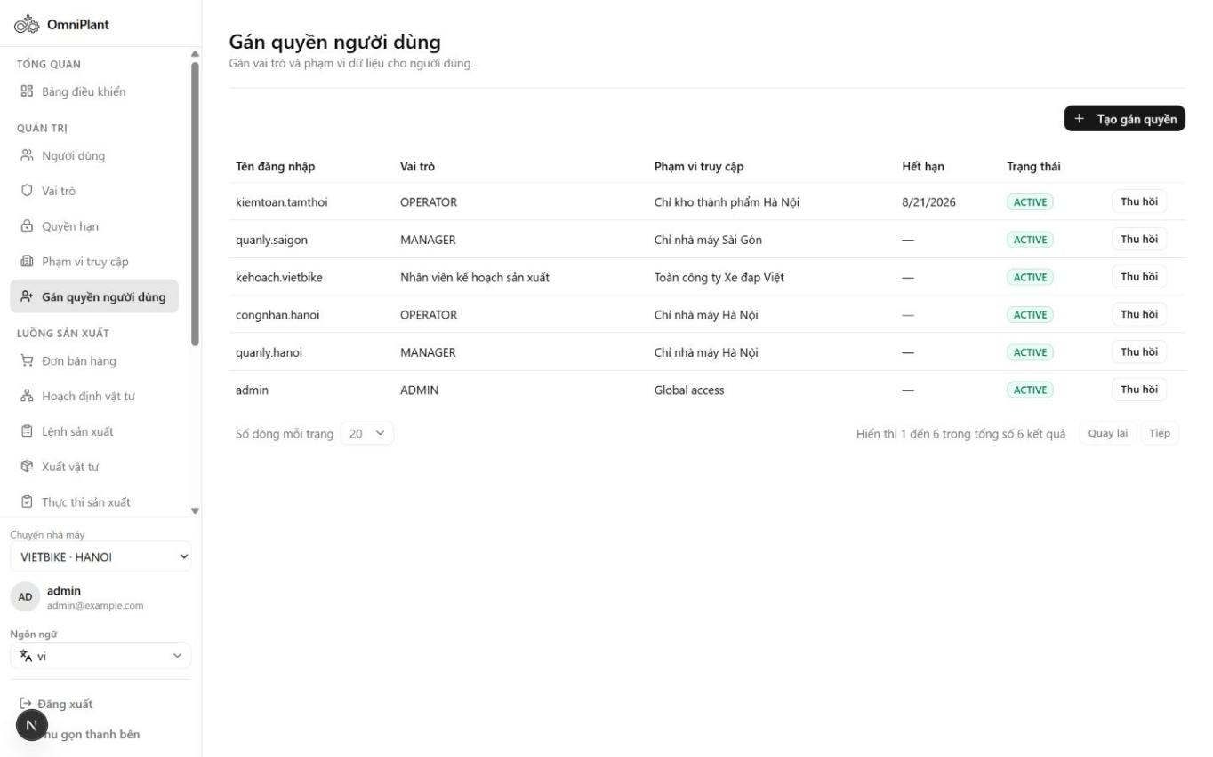
Figure 33. User Assignment form linking User, Role and Scope

Organization Structure
This screen represents the Company, Plant and Warehouse hierarchy used throughout OmniPlant. The structure provides the organizational context for inventory, production and scoped authorization.
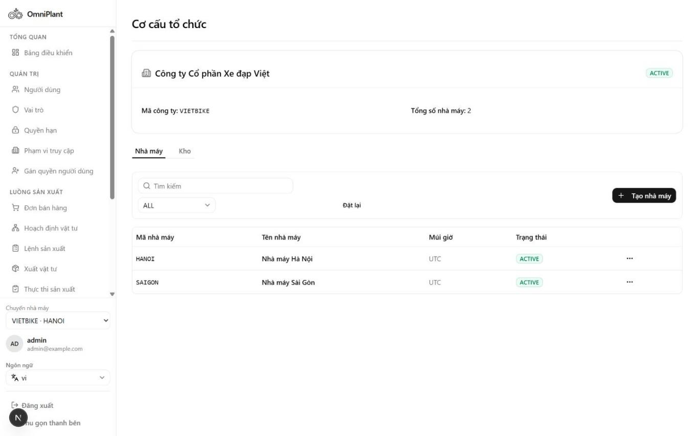
Figure 34. Organization structure with Company, Plant and Warehouse evidence

Unit of Measure Management
This screen maintains reusable units of measure for item and transaction data. Standardized codes help keep quantities consistent across BOM, inventory and production workflows.
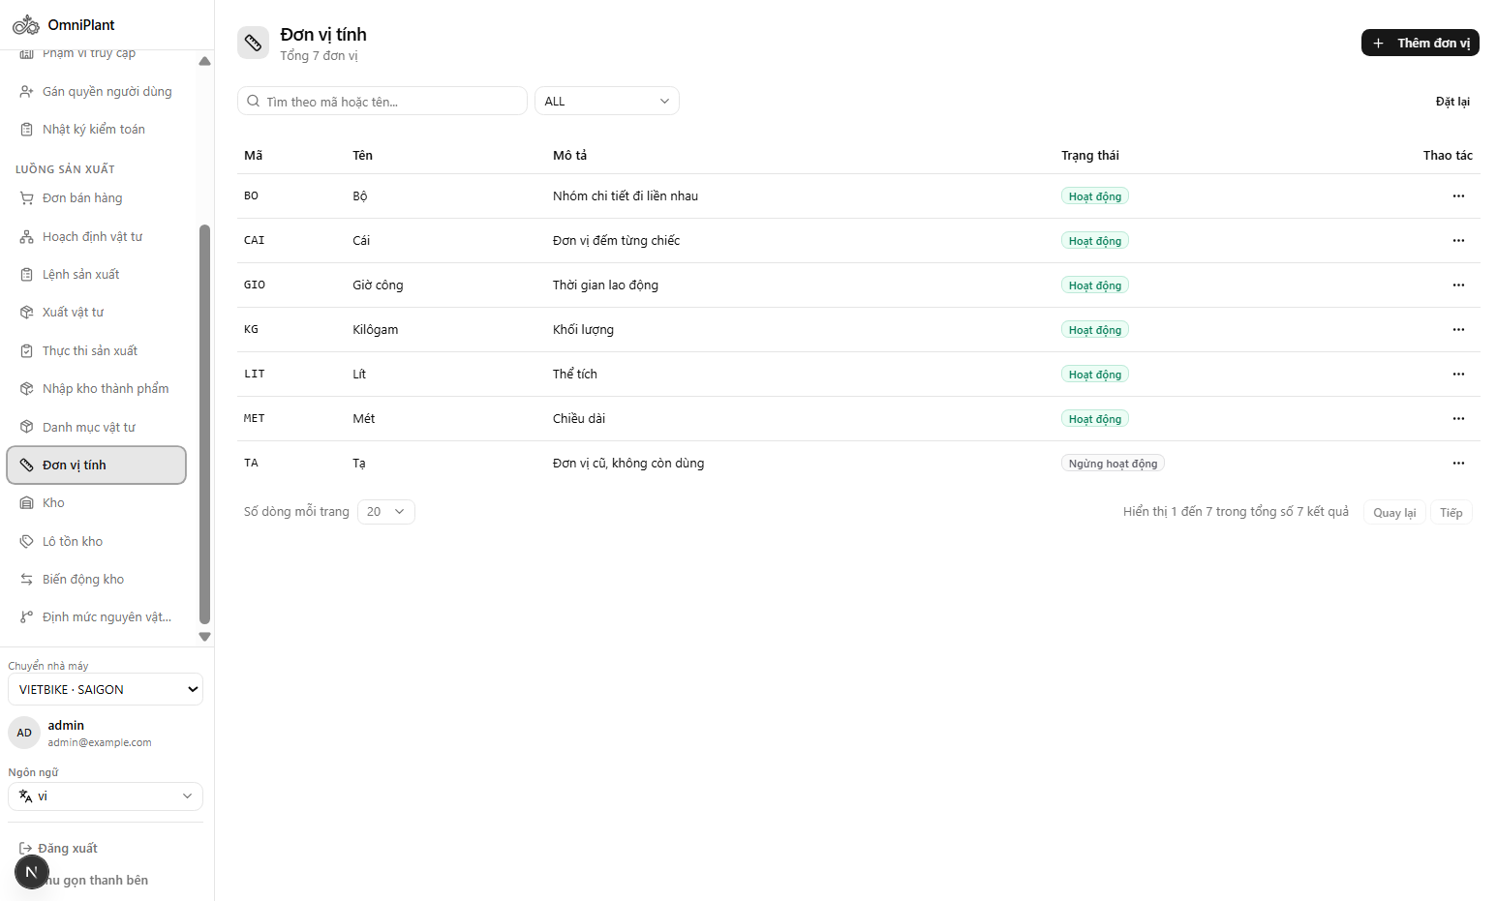
Figure 35. UOM management with reusable measurement codes

Audit Logs
This screen provides evidence of sensitive system and data changes. Actor, entity, action and timestamp fields support accountability and operational review.
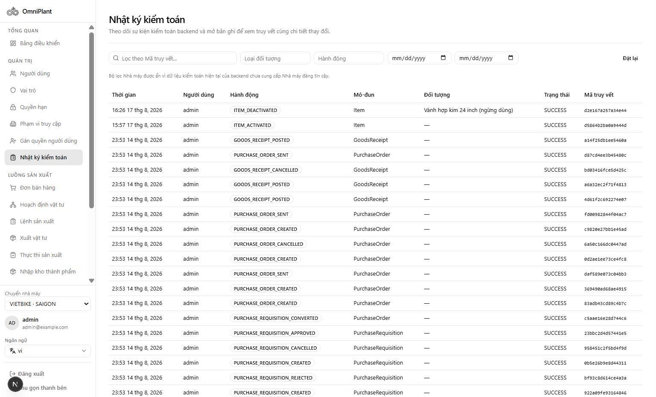
Figure 36. Audit Logs with actor, entity, action and timestamp evidence

Validation and Acceptance Results
The earlier report snapshot recorded 59 Vitest files and 265 passing tests. The 27 August 2026 repository run recorded in the review evidence reports 78 files and 348 passing tests. These are frontend, domain/mock, component, authorization-evaluator and API-contract tests; they do not prove PostgreSQL rollback, row locking or concurrent-reservation safety. Historical live acceptance is reported separately below. Outstanding backend evidence is identified in the table below; no new test run is implied by this revision.
Gate | Recorded outcome
Frontend automated regression | 78 Vitest files / 348 tests passed in the 27 August 2026 recorded snapshot; earlier snapshot: 59 / 265. Scope: frontend/domain/mock/component/API-contract. Raw timestamped log and commit for that run remain to be archived.
Backend unit tests | Pending: no backend unit-test report/version is attached to this acceptance record. Do not infer a result from Vitest.
Backend PostgreSQL integration | Pending: export MRP fixture/expected-result, idempotency row-count and duplicate-lot rollback reports against the actual database.
Security / Plant live acceptance | Historical role and Plant-isolation acceptance was recorded on 6 August 2026. Backend repository/service negative-test evidence and current-version reruns remain pending.
Concurrency / fault injection | Pending: simultaneous reservations, timeout recovery, deadlock/retry and late-command rollback require separate database assertions.
Performance / rate limiting | Pending: agree p95/p99 targets, dataset, concurrency and limiter thresholds; then export measured latency, 429 and recovery results.
Other frontend gates | Earlier gates recorded strict TypeScript, API coverage checks, EN/VI parity, build/lint and desktop/tablet checks. These are separate client-quality evidence, not backend safety proof.
Inventory and audit acceptance | Historical production-path acceptance covers issue, receipt/HOLD and QC/AVAILABLE with role checks. Duplicate-lot rollback and concurrent reservation remain pending; audit UI evidence is not full transition coverage.
Table 9. Quality and acceptance evidence
Pending backend evidence must identify the test timestamp, backend commit/version, database/migration version, fixture, command and assertions. Priority cases are duplicate-lot approval rollback; two reservations of 8 against stock 10; replay with the same key and changed payload; cross-Plant read/write denial; and multi-level MRP netting with Safety Stock, allocations and HOLD/REJECTED exclusion.

Operational Demonstration Result
The presentation fixture demonstrated a completed Planning Run containing two demands, eight requirement lines, six shortages, three MAKE suggestions and three BUY recommendations. Work Orders were exercised across PLANNED, RELEASED, BLOCKED, IN_PROGRESS and COMPLETED states. Execution evidence recorded good, scrap and rework quantities, while Production Receipts covered DRAFT, PENDING_APPROVAL, APPROVED/HOLD, QC AVAILABLE and QC REJECTED outcomes.
The demonstration also showed partial Sales Order fulfillment after QC AVAILABLE output, confirming that accepted finished goods flow back into business demand status rather than appearing only in an isolated inventory screen.

Engineering Discussion

Planning Run versus Standalone Production Estimation
Both functions use BOM explosion and stock comparison, but their business purposes differ. A standalone estimator answers an ad-hoc question about one product and target quantity. The Planning Run begins with confirmed demand, creates an auditable immutable snapshot, applies safety-stock netting, produces supply suggestions and continues into Work Orders. For this reason, the Planning Run is the authoritative Capstone Project 2 evidence and Production Estimation remains outside the focused scope.

Immutable Snapshots and Idempotency
Work Order snapshots preserve the engineering definition after BOM or Routing masters change. Idempotency is the separate requirement that repeated submission has one logical effect. Stable client keys and mock replay tests support that contract, but backend row-count and transaction tests are required before claiming persisted uniqueness. Historical Planning Run replay and conversion failures remain subject to verified reruns.

Availability and Quality Semantics
On-hand quantity alone is insufficient for planning. OmniPlant separates reservations and quality status so that only eligible stock becomes projected supply. The same rule is applied across Dashboard alerts, MRP, reservation, issue selection and Sales Order fulfillment. This consistency is more important than any single screen because a mismatch would produce false production readiness.

ERP Execution without MES
Capstone Project 2 records actual production manually rather than simulating machine integration. The interface captures quantities, times, actor and notes, while the model preserves an extensible execution-source boundary. This approach delivers a usable ERP process now and avoids misleading claims about real-time telemetry, OEE or automated shop-floor dispatching.

Known Limitations
- Full BUY-side execution is deferred; a BUY suggestion does not create a committed scheduled receipt in the focused MVP.
- Capacity is advisory and retained as a supporting master/scheduling seam; automatic finite optimization is not implemented.
- Approval and QC are separate permissions/actions, but a Manager may hold both and disposition a receipt they approved. No transaction-level same-user prohibition is currently enforced. A dedicated QC role alone would not prevent the issue when permissions overlap.
- Detailed manufacturing cost, labor/overhead valuation, OEE and profitability are not calculated.
- MES, PLC and IoT data are not integrated; all execution confirmation is manual.
- Historical live acceptance found identical Planning Run replay creating multiple runs and suggestion conversion behaving non-atomically. These failures require a rerun after backend fixes before being marked complete. The frontend test total is not evidence that either database defect has been resolved.
Full-Kit reservation is a fixed MVP policy. Operation-level material staging, progressive release and authorized shortage overrides are not implemented; staged deliveries can therefore delay otherwise feasible early operations.
Atomic in-memory/domain behavior does not prove PostgreSQL rollback. Duplicate-lot receipt-approval rollback and concurrent material reservation still require current backend integration/live evidence. Performance, rate limiting and fault-injection acceptance are also pending.

CONCLUSION AND FUTURE WORK

Conclusion
Capstone Project 2 converted OmniPlant from an analysis-and-prototype project into an integrated Manufacturing ERP application with a coherent operational spine. The system captures customer demand, performs material planning, creates and controls Work Orders, preserves inventory and lot traceability, records manual production execution, approves output and enforces a quality gate before finished goods become available.
The implementation establishes a focused foundation of permissions, Plant scoping, immutable snapshots, inventory movements, explicit states and ERP list/form workspaces. Its assurance is bounded by the evidence in Section 4.3: backend concurrency, rollback, idempotency reruns and measured performance/rate limiting still require acceptance. These gaps must be resolved before claiming production-level transaction safety.
The most important project result is the continuity of evidence. A reviewer can navigate from a Sales Order line through an immutable Planning Run and Work Order to issued material lots, WIP confirmation, Production Receipt, QC outcome and output inventory. This continuity is the defining achievement of the Capstone Project 2 scope.

Future Work
Four extensions are planned for Capstone 3. They are presented in the order in which they should be delivered, which is the order of the operational risk each one removes: completing external supply, giving Work Orders a schedule, loading master data at a realistic volume, and handling the exception paths on which a working factory depends.
The first extension completes the Purchasing chain: Supplier, Purchase Requisition, Purchase Order and Goods Receipt. A BUY recommendation currently ends as advice, because nothing records what was ordered, what is due to arrive or what was actually delivered. Material planning therefore works from on-hand stock alone and repeatedly proposes purchases that have already been placed. Closing the chain links each recommendation to an approved order and a received quantity, posts the receipt into HOLD stock for incoming inspection, and releases accepted material to AVAILABLE stock, with the source requirement and the Plant remaining linked throughout. This removes a significant remaining source of incorrect quantities in the system.
The second extension puts Routing into operational use. Work Centres and operation times, covering setup time and run time per unit, define where each operation of a Work Order is performed and how long it should take. The Work Order can then calculate an expected start and finish for every operation against the calendar of its Work Centre, and the finish of the last operation becomes the date on which the order can be promised. Without this information a delivery date is an estimate; with it, the date is derived from the routing the factory will actually follow.
The third extension is a spreadsheet import path for master data, following the sequence template, validate, apply. Items, Bills of Materials and opening stock are currently entered one record at a time through the user interface, which is not workable for a manufacturer with a catalogue of several thousand parts. Validation runs as a separate step that reports errors by row and column without writing anything, so that a file can be corrected and resubmitted, and the apply step commits only a file that has passed validation. This makes the initial data load, and any later bulk update, an operational task rather than a manual one.
The fourth extension covers the business exception branches. The current implementation follows the main path from confirmed demand to quality-released output, but a working factory spends much of its time outside that path. Partial and staged deliveries, cancellation of a document that has already produced effects, returns and reversals, authorized over-issue and shortage overrides, rework repeated across several attempts, replanning after a change in demand or in a BOM, and lot expiry all require defined behaviour and defined states. Completing these branches is what moves OmniPlant from a system that works in a demonstration to a system that can be deployed.
Field validation will involve a participating assembly manufacturer and representative sample orders, BOMs and stock records supplied with permission. The study will record a manual-process baseline and repeat the same tasks in OmniPlant. It will compare planning time, quantity reconciliation errors, trace retrieval time and user task completion. Documented observations will guide changes to the core workflow, and the findings will report measured results and sample limitations. This validation is planned and has not yet been completed.

REFERENCES
[1] X. Cirera, D. Comin, M. Cruz, K. M. Lee and A. Soares Martins-Neto, "Firm-Level Technology Adoption in Vietnam," World Bank Policy Research Working Paper 9567, March 2021, Sec. 4.1. doi: 10.1596/1813-9450-9567. https://documents1.worldbank.org/curated/en/498501615216149075/pdf/Firm-Level-Technology-Adoption-in-Vietnam.pdf. Accessed 10 September 2026.
[2] N. A. Hoa, "Triển khai thi hành Luật Đất đai năm 2024 góp phần tháo gỡ khó khăn, vướng mắc trong thực tiễn của tỉnh Bình Dương," in Tài liệu Hội nghị phổ biến, quán triệt Luật Đất đai năm 2024 của ngành Tư pháp, Ministry of Justice, 21 March 2024, opening paragraph. https://www.moj.gov.vn/qt/tintuc/Pages/chi-dao-dieu-hanh.aspx?ItemID=4215 (attached conference proceedings). Accessed 10 September 2026.
[3] Nguyễn Thanh Phương, Võ Xuân Vinh and Huỳnh Thị Phương Dung, "Các yếu tố ảnh hưởng đến chuyển đổi số tại các doanh nghiệp nhỏ và vừa: Nghiên cứu trên địa bàn Bình Dương (cũ)," Tạp chí Địa lý nhân văn và Phát triển bền vững, Kỳ Phát triển bền vững Vùng, vol. 16, no. 1, 2026, published 18 June 2026, abstract. https://vjol.info.vn/vienncptbvvung/vi/article/view/153229/. Accessed 10 September 2026.
[4] Softengine, Inc., "Green Line Botanicals: Organic Beauty Line Grows with SAP Business One," SAP Business One Customer Success Story, pp. 1-2, n.d. https://softengine.com/wp-content/uploads/2021/12/FINAL-Green-Line-Botanicals-edited.pdf. Accessed 10 September 2026.
[5] U. Sayed, "ERPNext Implementation at CVS Group, UAE," Frappe Blog, 29 January 2019. https://frappe.io/blog/community-stories/erpnext-implementation-at-cvs-group-uae. Accessed 10 September 2026.
[6] Frappe Technologies, "Why should businesses use an ERP?," ERPNext Documentation. https://docs.frappe.io/erpnext/why-ERP. Accessed 10 September 2026.
[7] Tâm Anh, "Nâng cao năng lực chuyển đổi số cho doanh nghiệp nhỏ và vừa ở Bình Dương," VietNamNet, coverage of the provincial SME digital-transformation workshop (event date documented in [8]). https://vietnamnet.vn/chuyen-doi-so-cho-doanh-nghiep-vua-va-nho-binh-duong-2059118.html. Accessed 10 September 2026.
[8] Agency for Enterprise Development, "Chuyển đổi số cho doanh nghiệp nhỏ và vừa tỉnh Bình Dương: Góc nhìn người triển khai," event announcement, 16 August 2022. https://digital.business.gov.vn/event/chuyen-doi-so-cho-doanh-nghiep-nho-va-vua-tinh-binh-duong-goc-nhin-nguoi-trien-khai/. Accessed 10 September 2026.

APPENDIX

A.1. Focused MVP Screen Inventory
Navigation group | Visible MVP workspaces
Overview | Dashboard
Admin | Users; Roles; Permissions; Access Scopes; User Assignments
Demand and planning | Sales Orders; Material Planning; Planning Run Detail
Production | Work Orders; Material Issues; Production Execution; Production Receipts
Manufacturing foundation | Item Master; UOM; Stock; Inventory Lots; Stock Movements; BOM
Table 10. Focused Capstone Project 2 MVP navigation

A.2. End-to-End Demonstration Checklist
- Authenticate as Manager and select an authorized Plant.
- Verify active Item, UOM, Warehouse, BOM and eligible inventory data.
- Create and confirm a Sales Order with positive quantity and due date.
- Run Material Planning and inspect requirements, shortage messages and MAKE/BUY suggestions.
- Approve and convert an eligible MAKE suggestion into a Work Order.
- Under the current FULL_KIT MVP policy, reserve 100% of BOM-snapshot components before release; confirm that partial coverage blocks release without reducing on-hand stock.
- Post Material Issue using eligible lot/serial stock and confirm the movement/trace.
- Record manual execution good, scrap, rework and actual time.
- Create and submit a Production Receipt as Operator; approve it into HOLD as an authorized Manager. Verify that rejection posts no inventory.
- Perform QC as a separate action and verify AVAILABLE or REJECTED output eligibility. The same Manager may currently approve and QC; this does not demonstrate transaction-level maker-checker enforcement.
- Verify Sales Order fulfillment, inventory lot, stock movement, Dashboard and genealogy links.

